Azure Virtual Machines

# 1. What is Azure Virtual Machine?

Azure Virtual Machine (VM) is a cloud-based computing service that provides on-demand, scalable computing resources in Microsoft's Azure cloud platform. Virtual machines allow you to run applications and operating systems in a virtualized environment without the need for physical hardware.

# Key Benefits:

* **Cost-effective:** Pay only for the resources you use
* **Scalable:** Easily increase or decrease computing power as needed
* **Flexible:** Choose from various operating systems (Windows, Linux distributions)
* **Accessible:** Connect from anywhere with internet access
* **Managed:** Azure handles the underlying infrastructure maintenance

Azure VMs are ideal for development, testing, hosting applications, and learning cloud technologies. In this lab, we'll create both Ubuntu (Linux) and Windows virtual machines to demonstrate different use cases and connection methods.

# 2. Ubuntu Virtual Machine Setup

### Prerequisites: Download Required Tools

Before creating your Ubuntu VM, you'll need to download the necessary SSH clients.

#### Step 1: Download PuTTY

1. Visit the official PuTTY website: <https://www.putty.org/>

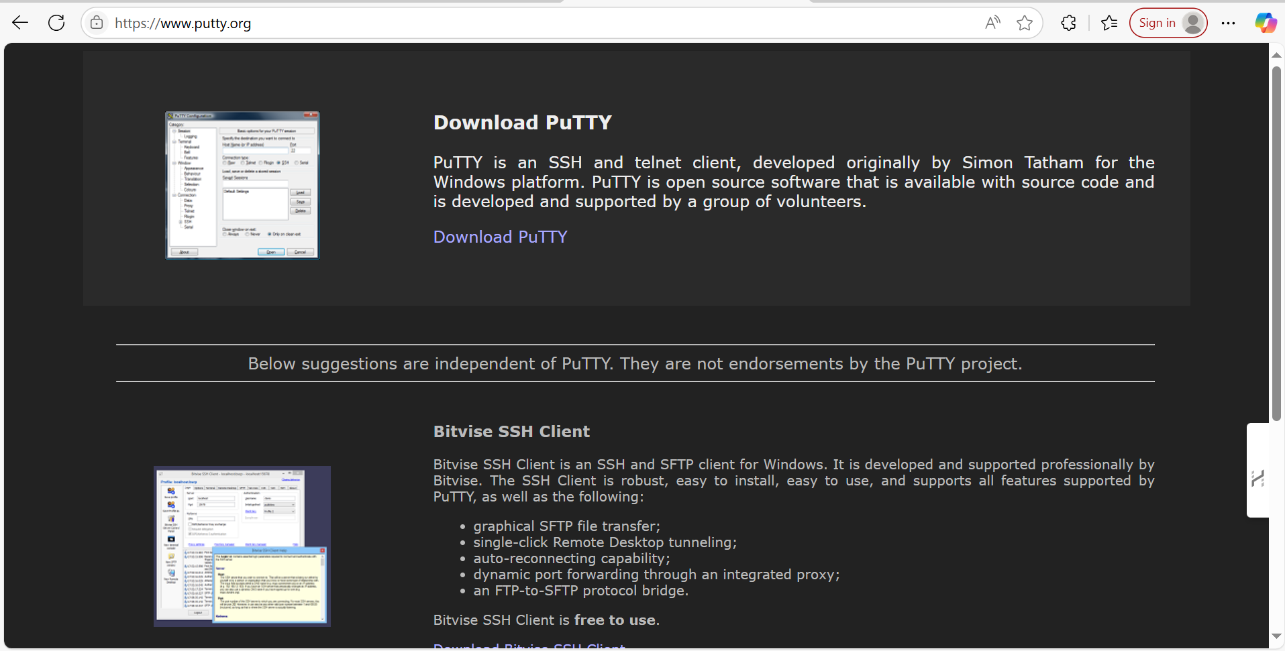

1. Download the Windows installer package (putty-64bit-0.83-installer.msi)

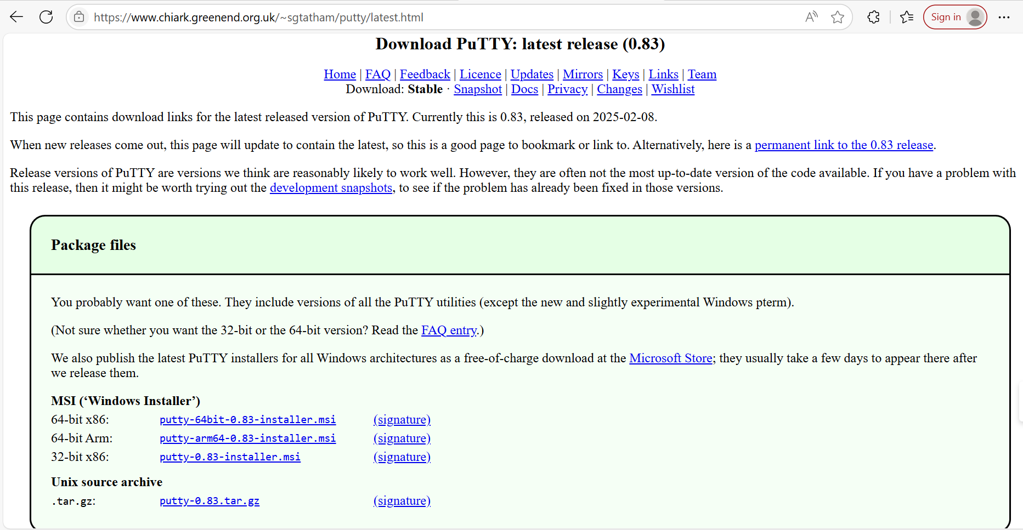

1. Install PuTTY on your local machine

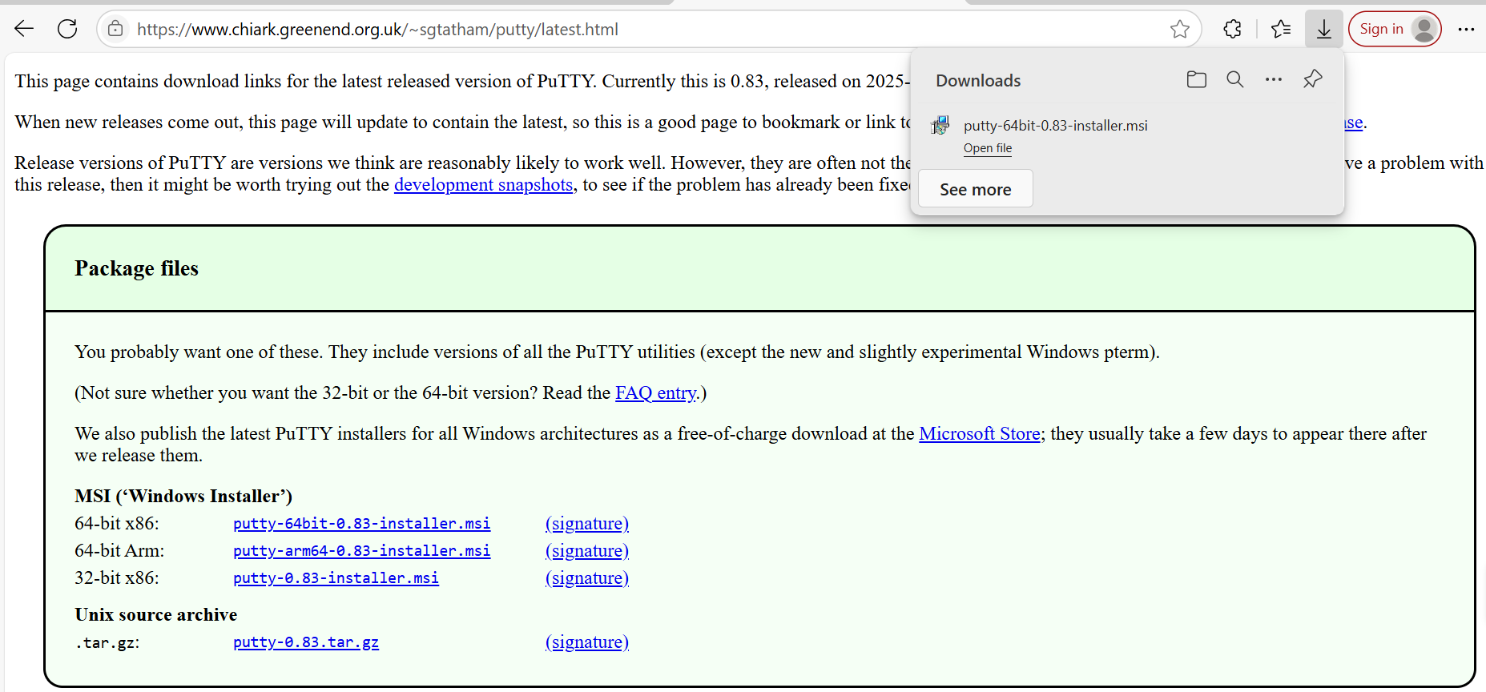

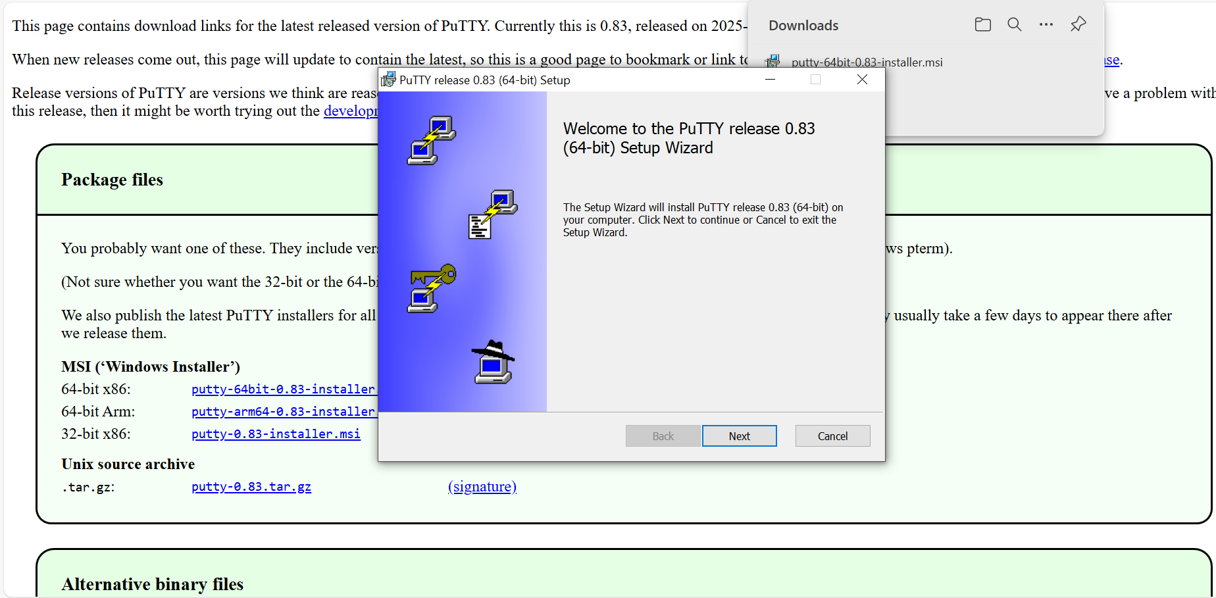

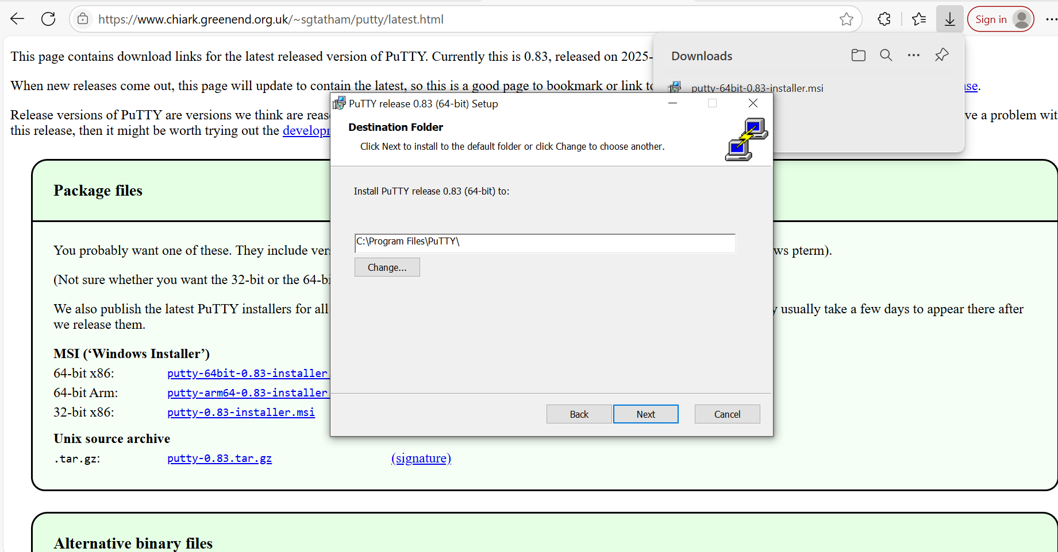

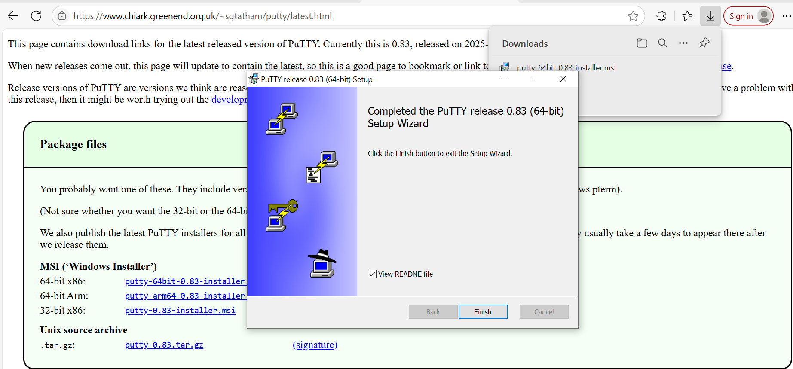

Congratulations! Successfully downloaded PuTTY

### Step 2: PuTTY Key Generator (PuTTYgen)

1. Once you [install the PuTTY](https://www.puttygen.com/download-putty) on your machine, you can easily run PuTTYgen. For the same, go to Windows -> Start Menu -> All Programs -> PuTTY -> PuTTYgen.
2. You will see the PuTTY key generator dialog box on your screen
3. You will find a “Generate” button in that dialog. Clicking on it will lead to generating the keys for you.

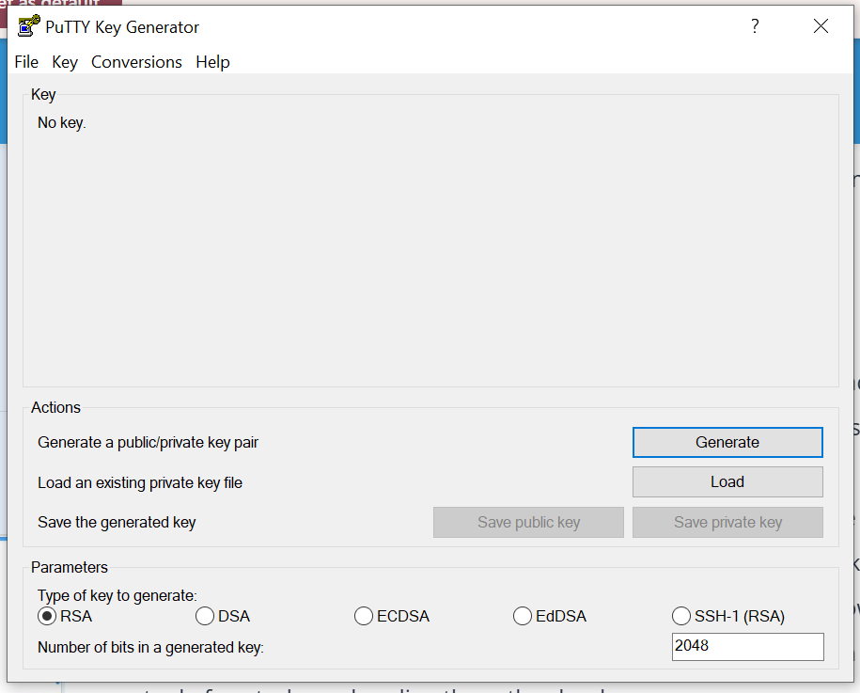

1. Now you will need to add a unique key passphrase in the Key passphrase and Confirm passphrase field.
2. Click on the “Save Public Key” and “Save Private Key” buttons to save your public and private keys.

## Creating an Ubuntu Virtual Machine

#### Step 3: Access Azure Portal

1. Log into your Azure account at [portal.azure.com](https://portal.azure.com)
2. Navigate to the Azure Dashboard

#### Step 4: Start VM Creation

1. Click on "Virtual machines" from the Azure services menu

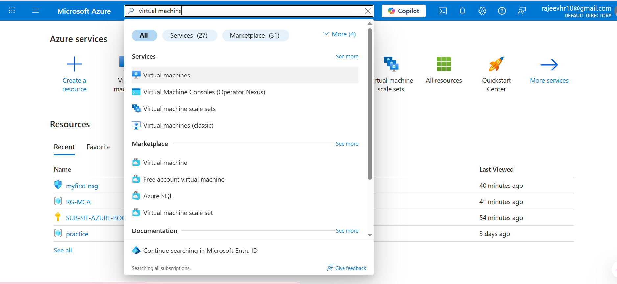

1. Click the "+ Create" button

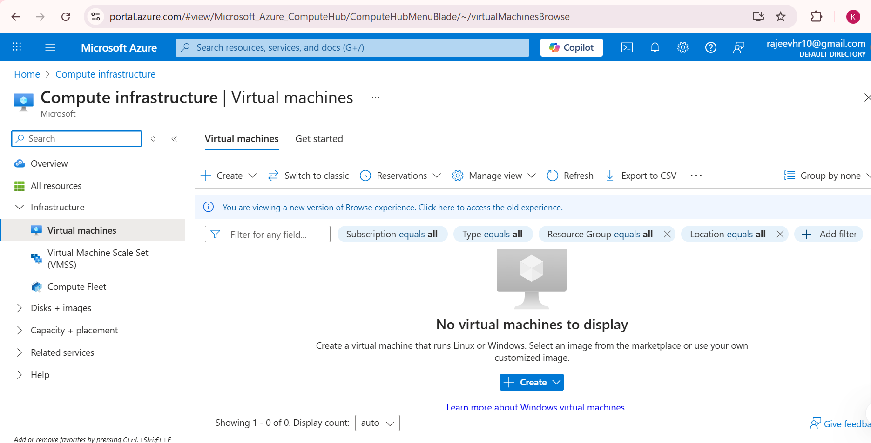

1. Select "virtual machine"

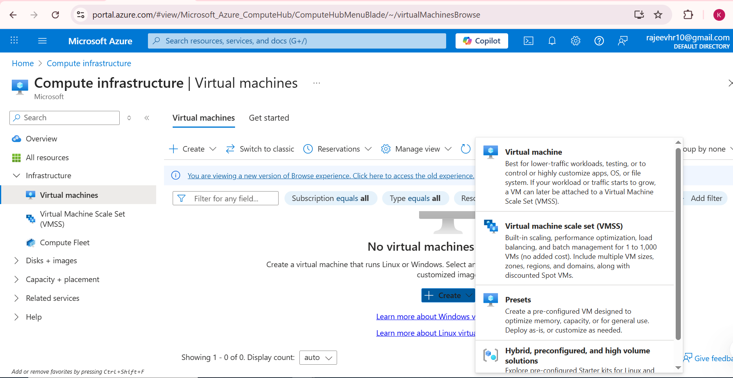

### Step 5: Configure Basic Settings

Fill in the following information:

* **Subscription:** Select your Azure subscription

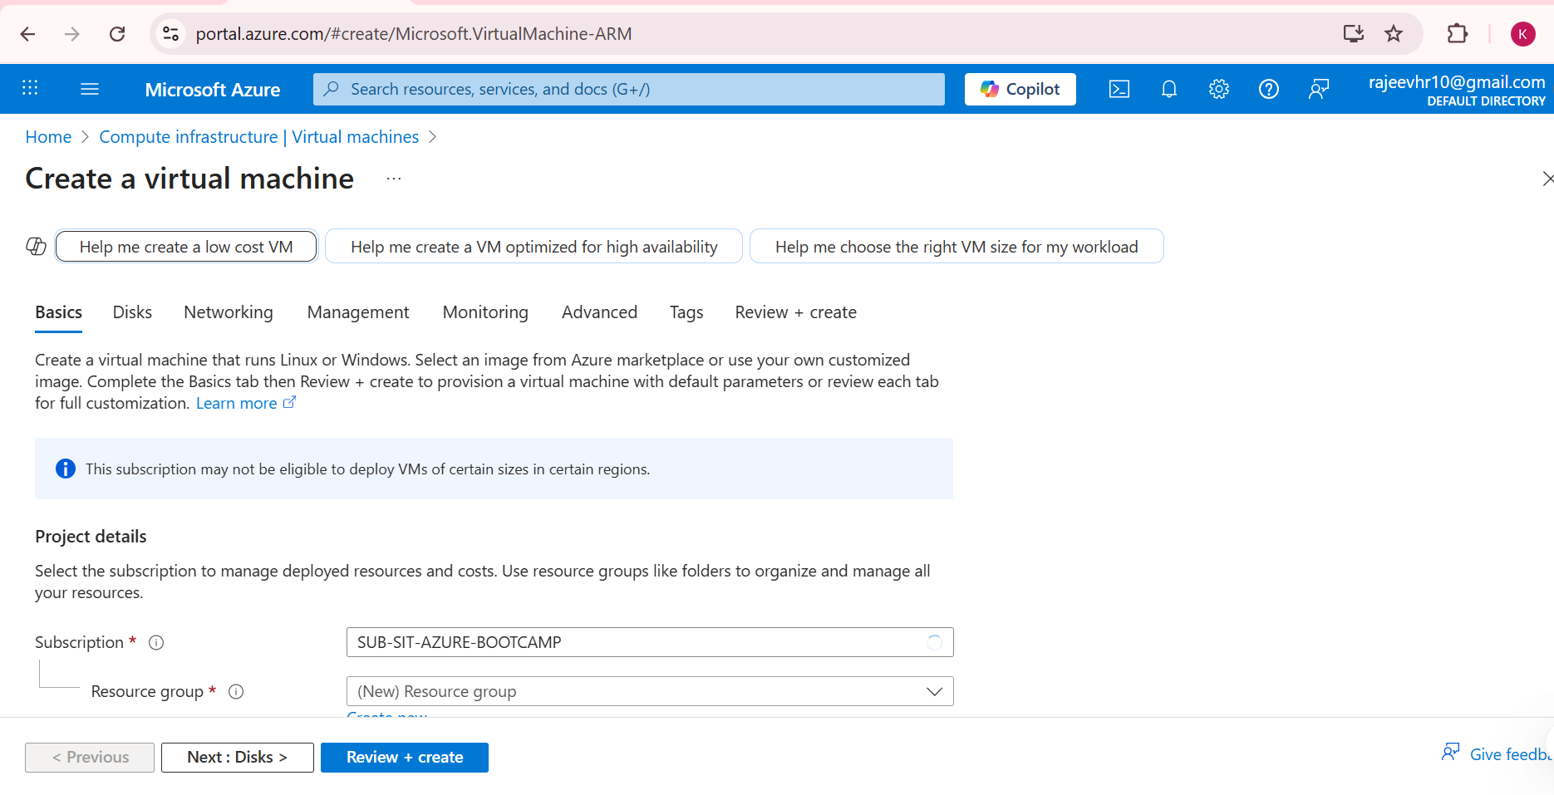

* **Resource Group:** Create a new resource group or select an existing one

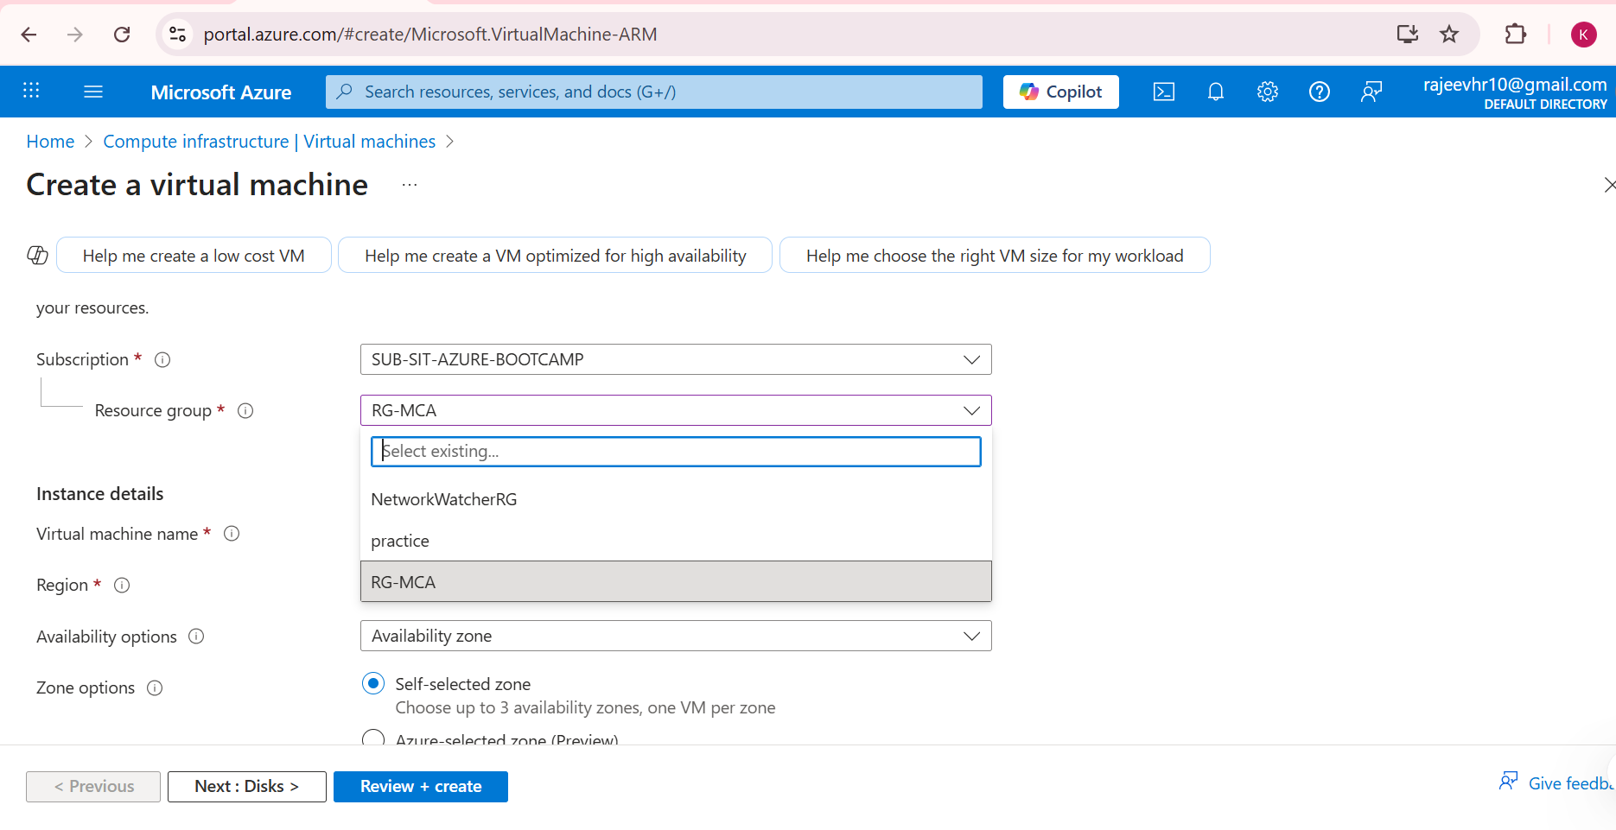

* **Virtual machine name:** Enter a descriptive name (e.g., "my-first-vm")

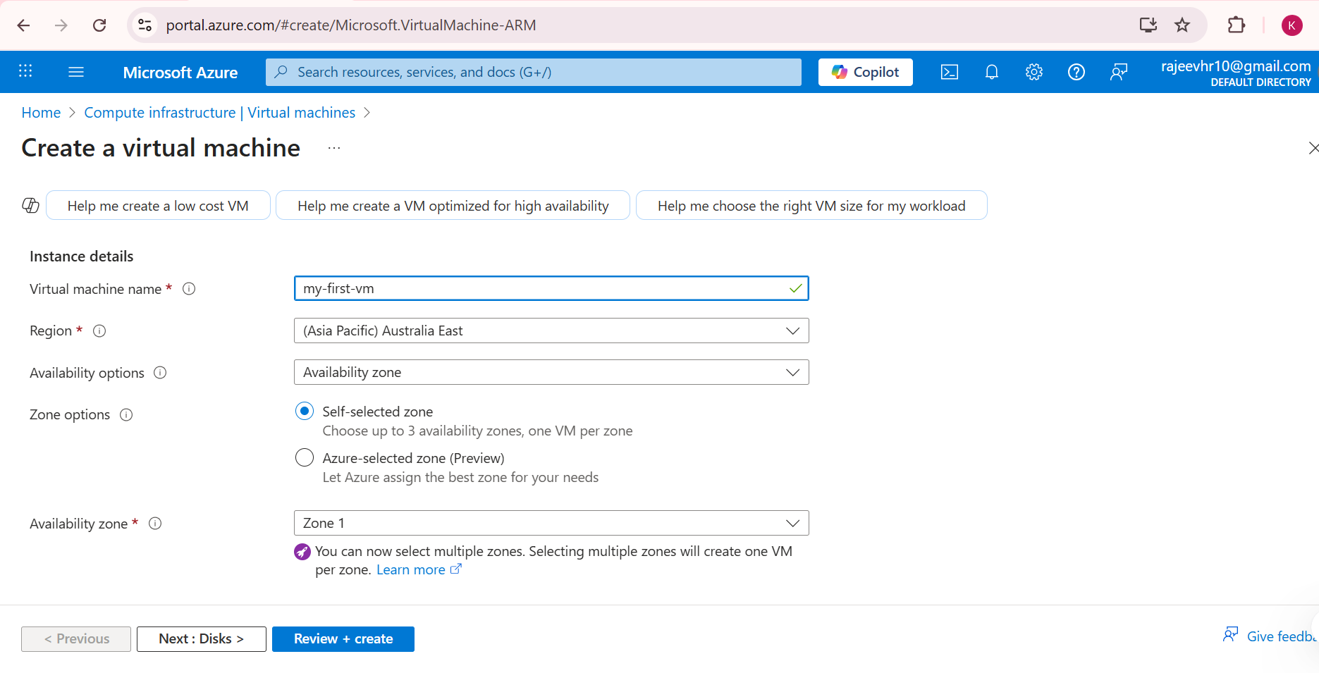

* **Region:** Choose a region closest to your location (ex: Asia pacific – Australia East)
* **Availability options:** Leave as default

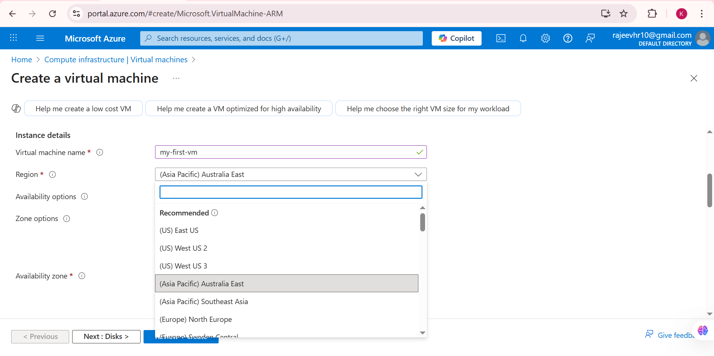

#### Step 6: Select Ubuntu Image

1. **Image**: Search for and select "Ubuntu Server 20.04 LTS" or latest version

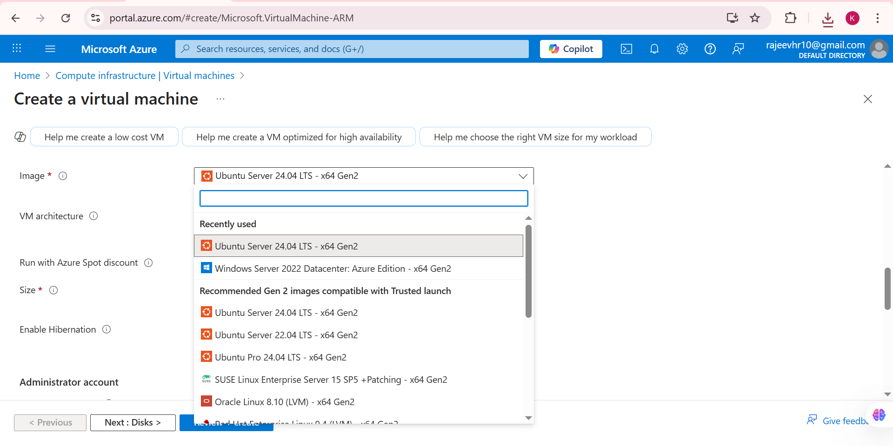

1. **Size**: Choose "Standard_B2as_v2 – 2vcpus"

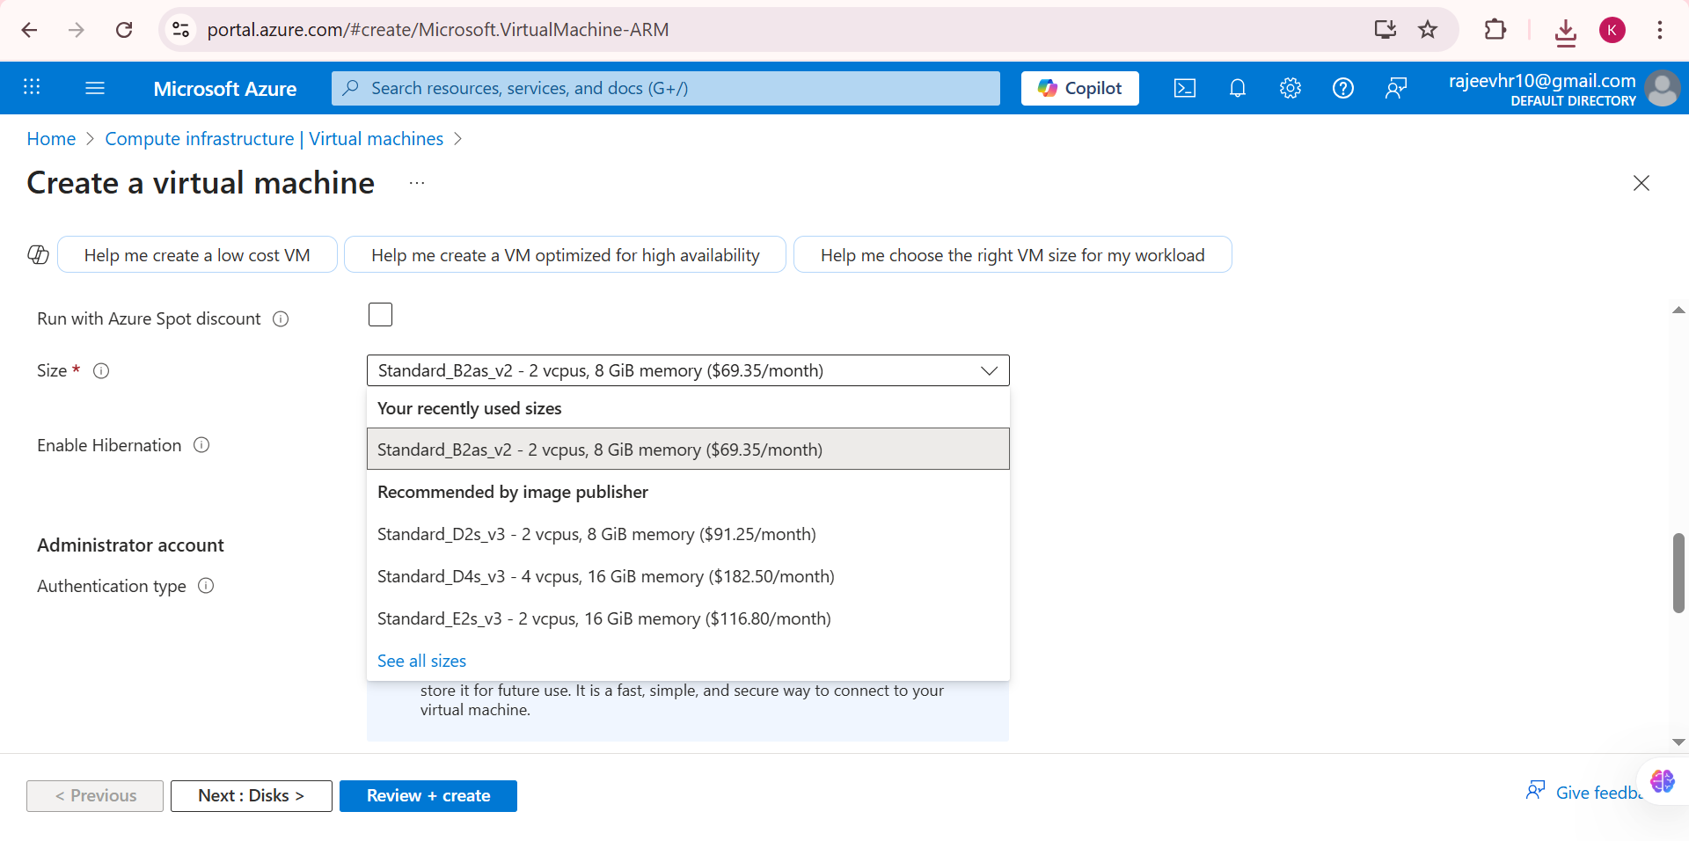

#### Step 7: Configure Authentication

1. **Authentication type**: Select "SSH public key"
2. **Username**: Enter "azureuser" (or your preferred username)
3. **SSH public key source**: Select "Generate new key pair"

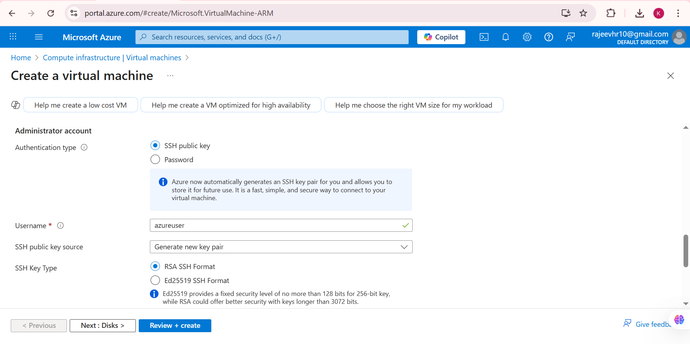

1. **Key pair name**: Enter a name for your key pair

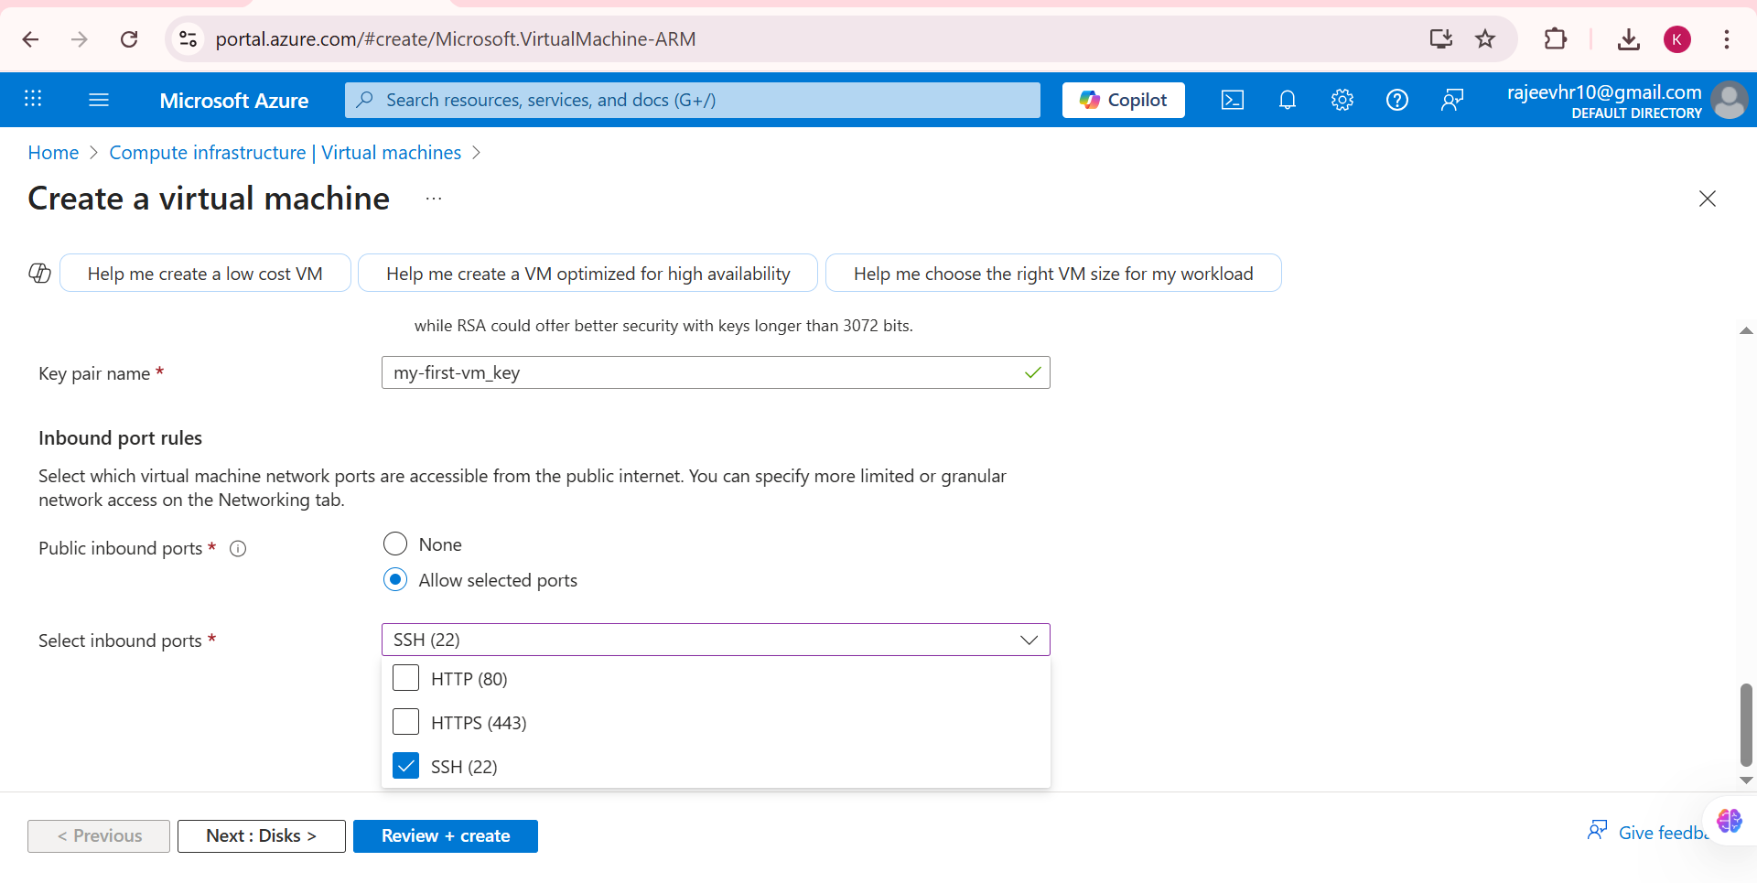

#### Step 8: Configure Networking

1. **Public inbound ports**: Select "Allow selected ports"
2. **Select inbound ports**: Choose "SSH (22)"



#### Step 9: Review and Create

1. Click "Review + create"
2. Review all settings carefully
3. Click "Create" to deploy the virtual machine

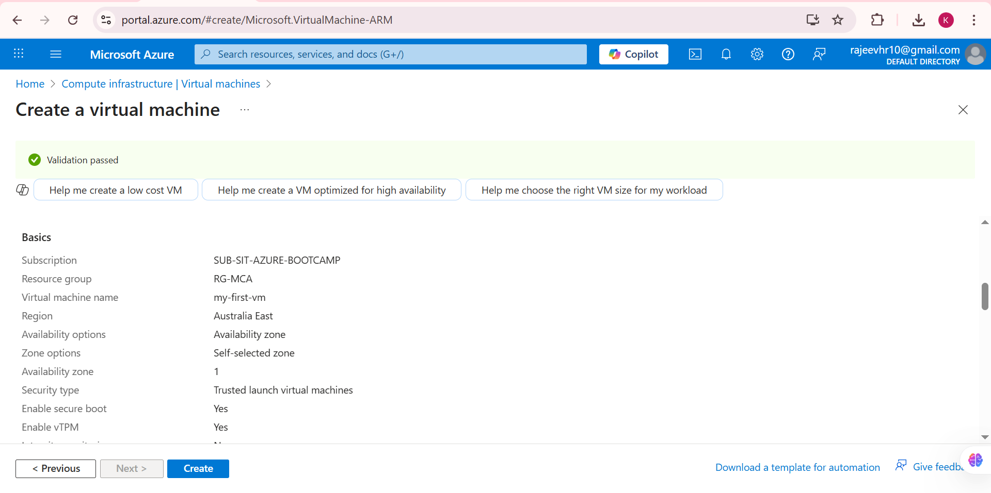

#### Step 10: Download Private Key

1. When the deployment dialog appears, download and save the private key (.pem file)
2. Store it securely as you'll need it for SSH connection

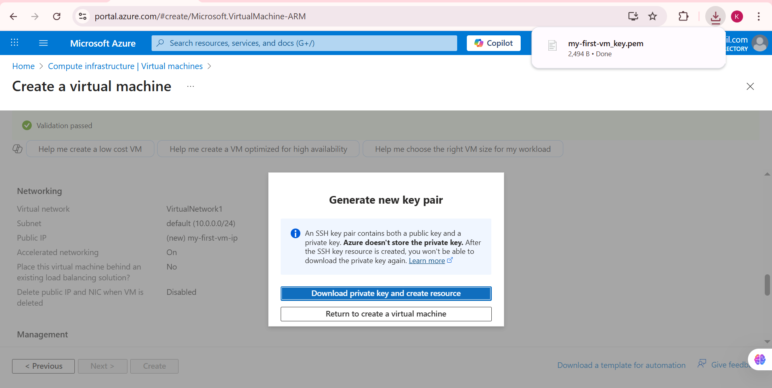

#### Step 11: Wait for Deployment

Monitor the deployment progress until it shows "Your deployment is complete"

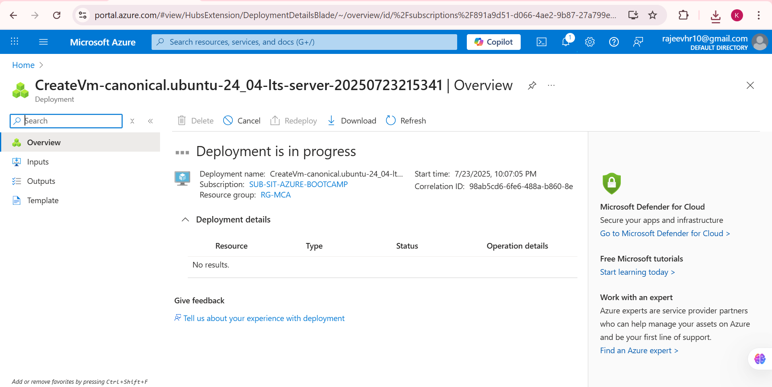

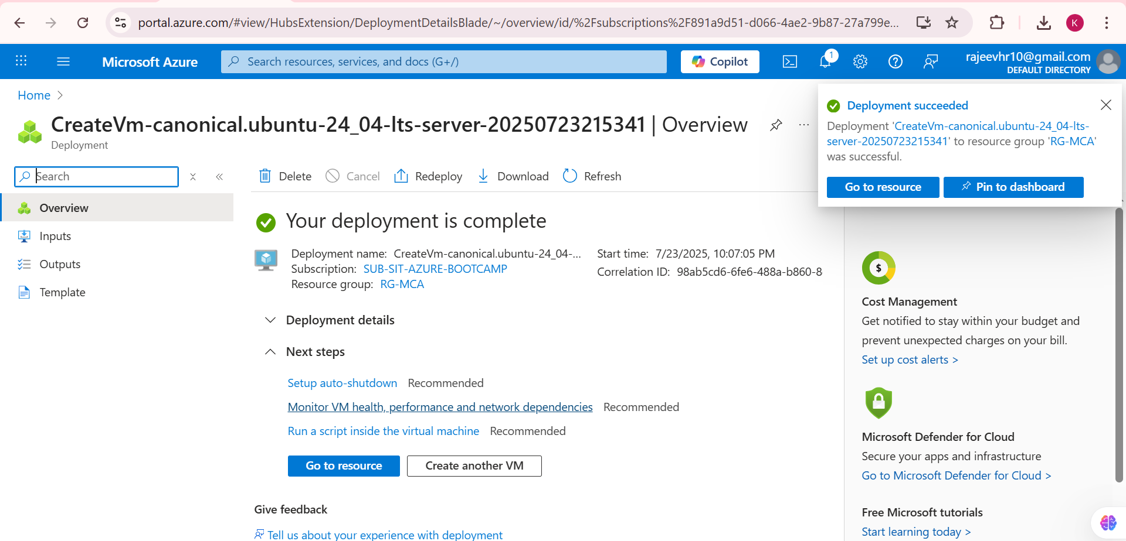

#### Step 12: Go to Resource

Click "Go to resource" to access your newly created VM

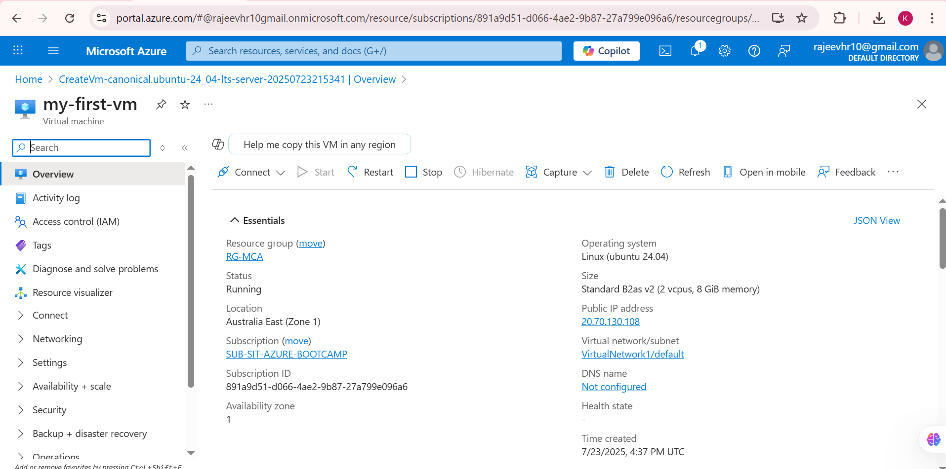

Click on the **“Connect”** button at the top.

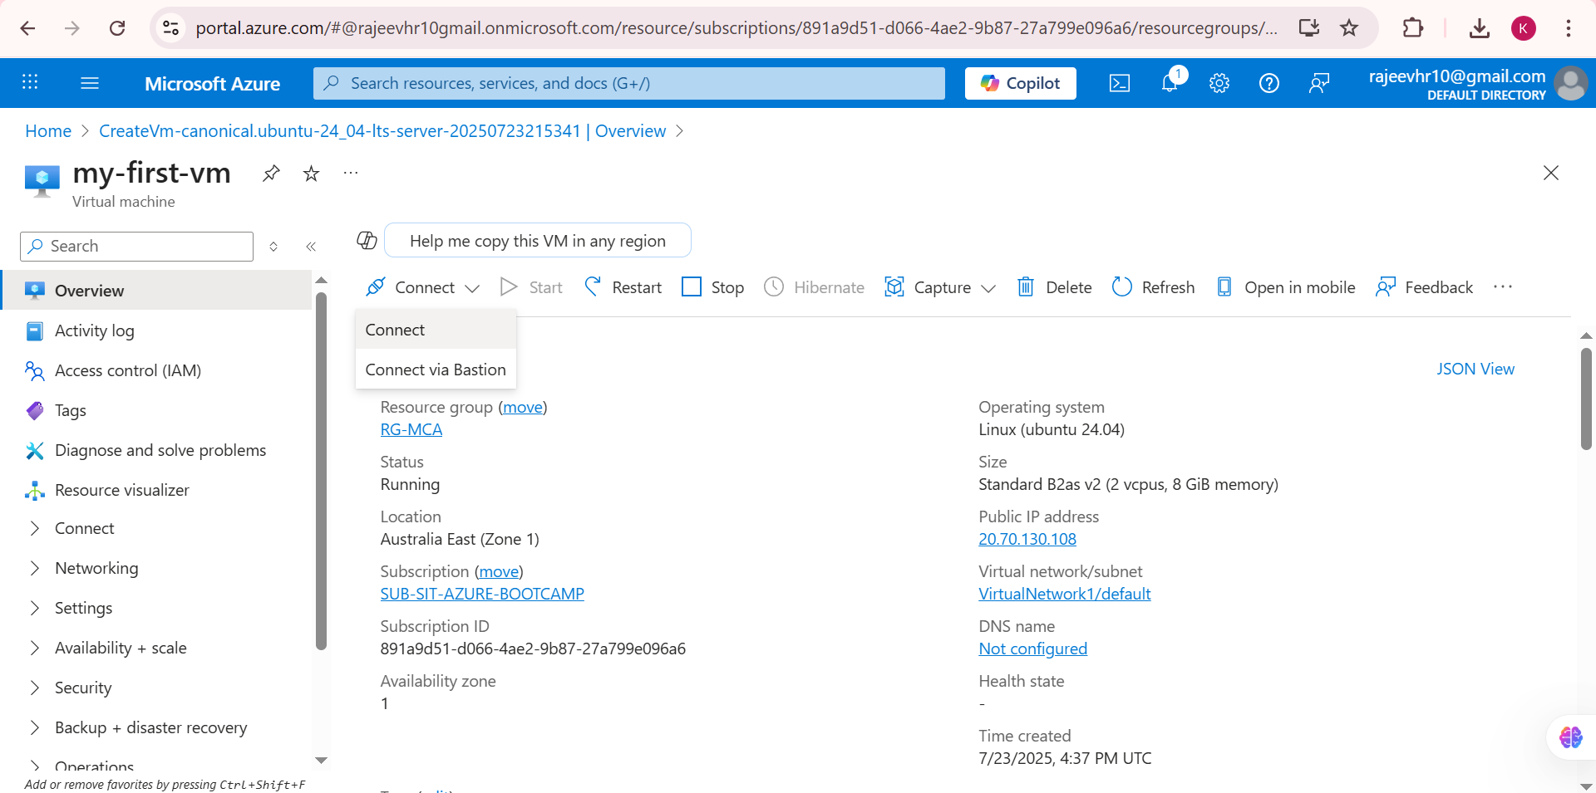

* Under “Recommended” connection methods, choose **SSH using Azure CLI**.
* Click **“Select”** under **SSH using Azure CLI**.

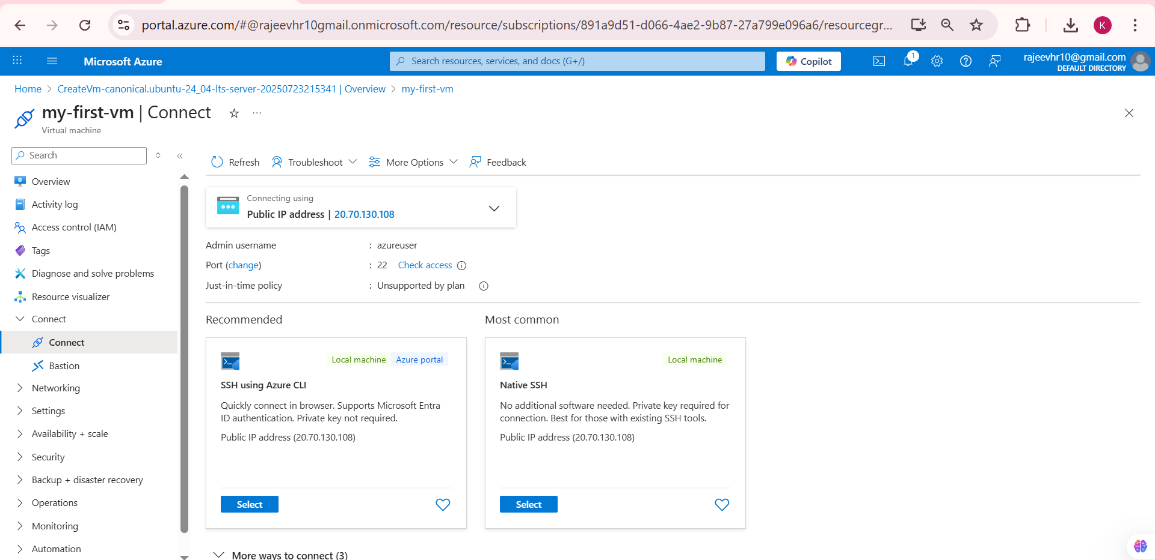

* Check the box: **“I understand just-in-time policy…”**
* Click on **“Configure + connect”** to initiate the SSH session via Azure CLI.

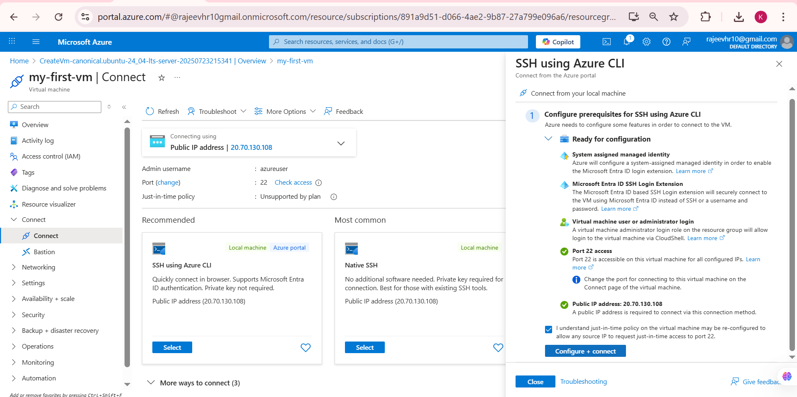

* The Azure Cloud Shell opens at the bottom.
* You’ll be prompted to verify the authenticity of the SSH host.
* Type yes when asked:  
  Are you sure you want to continue connecting (yes/no/[fingerprint])?

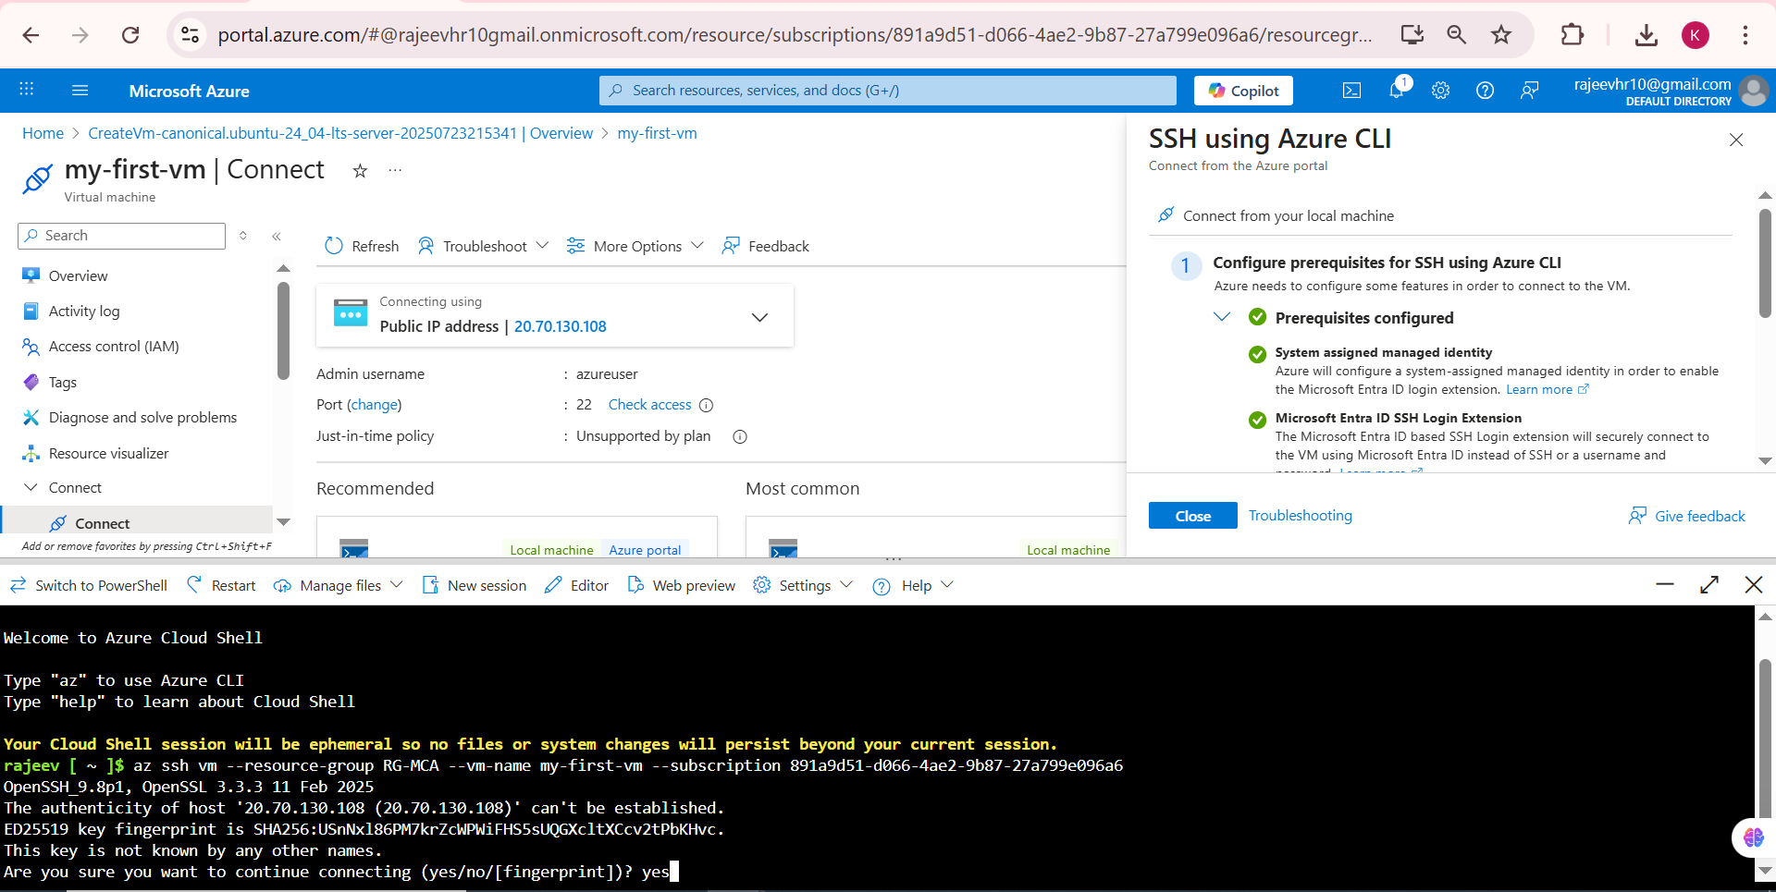

* Successfully Logged Into the VM

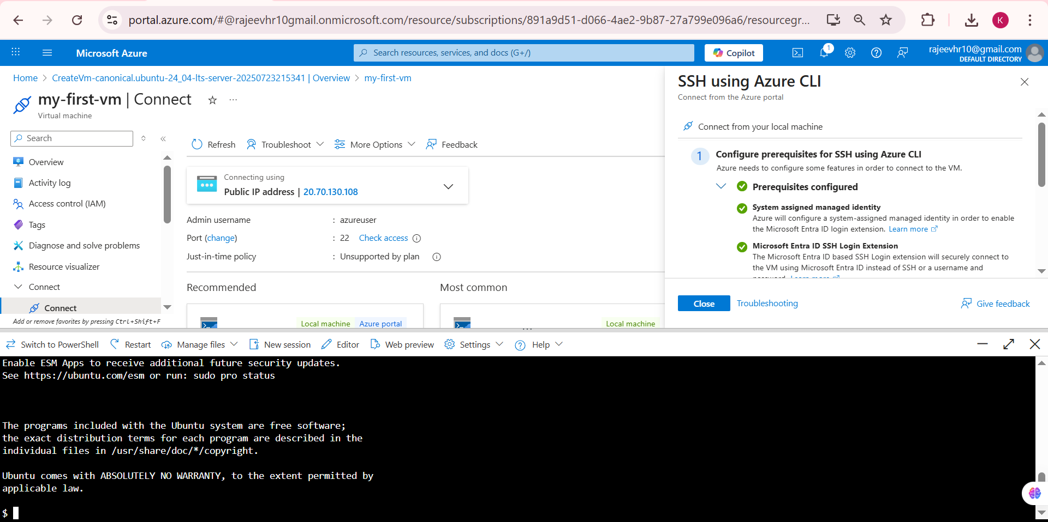

## Connecting to Ubuntu VM using PuTTY

#### Step 13: Convert .pem to .ppk using PuTTYgen

1. **Open PuTTYgen**
   * Launch the PuTTY Key Generator application

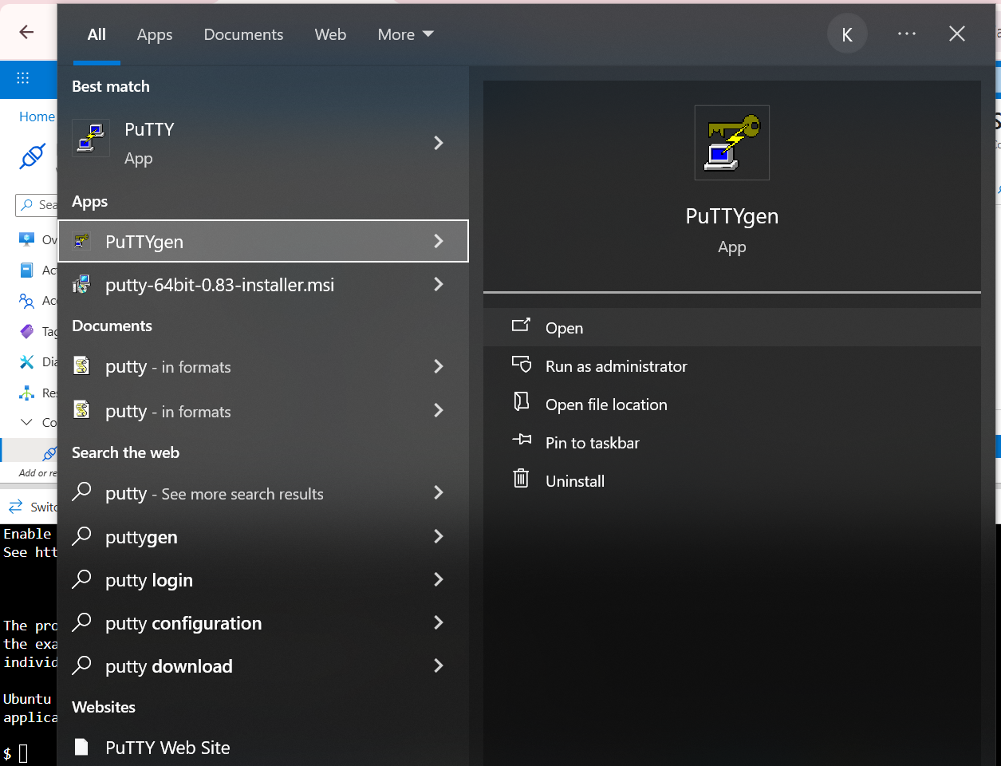

**Load the Private Key**

* Click "Load" button
* Change file type to "All Files (*.*)"
* Navigate to your Downloads folder
* Select the .pem file you downloaded from Azure
* Click "Open"

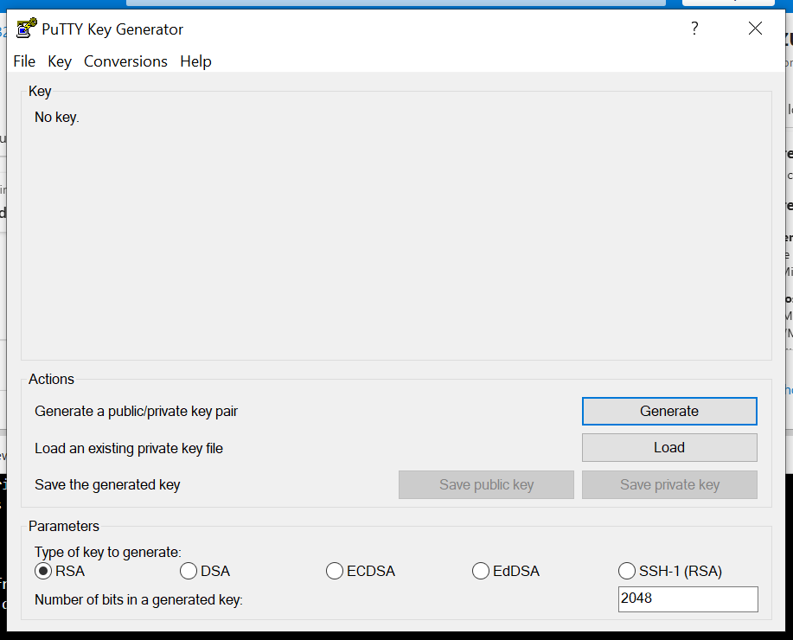

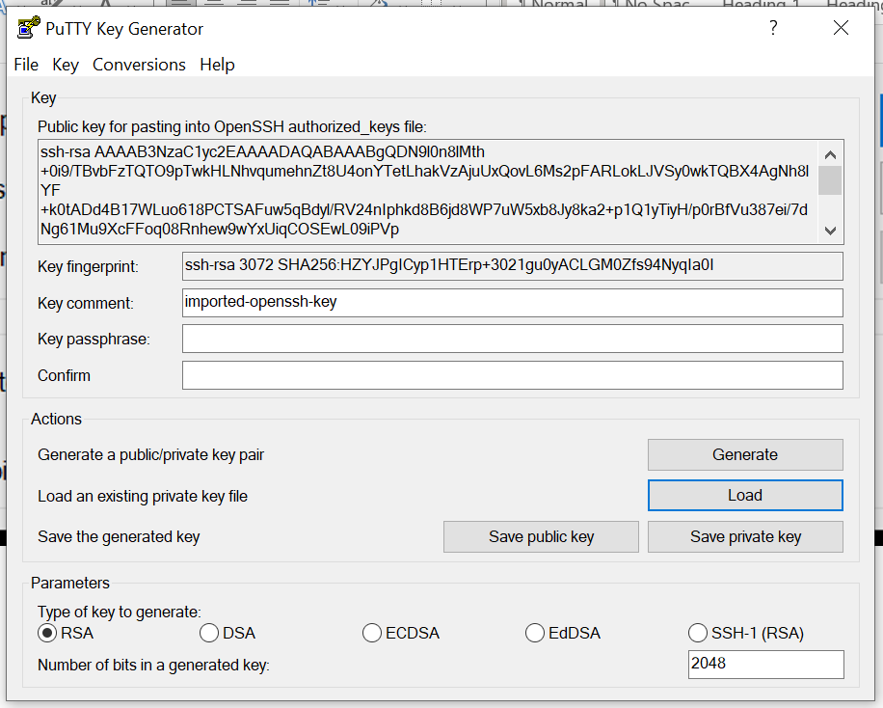

**Save Private Key**

* Click "Save private key"
* Choose "Yes" when prompted about saving without passphrase
* Save the file with .ppk extension in a secure location

#### Step 14: Get VM Public IP Address

1. In Azure Portal, go to your VM resource
2. Copy the Public IP address from the overview page

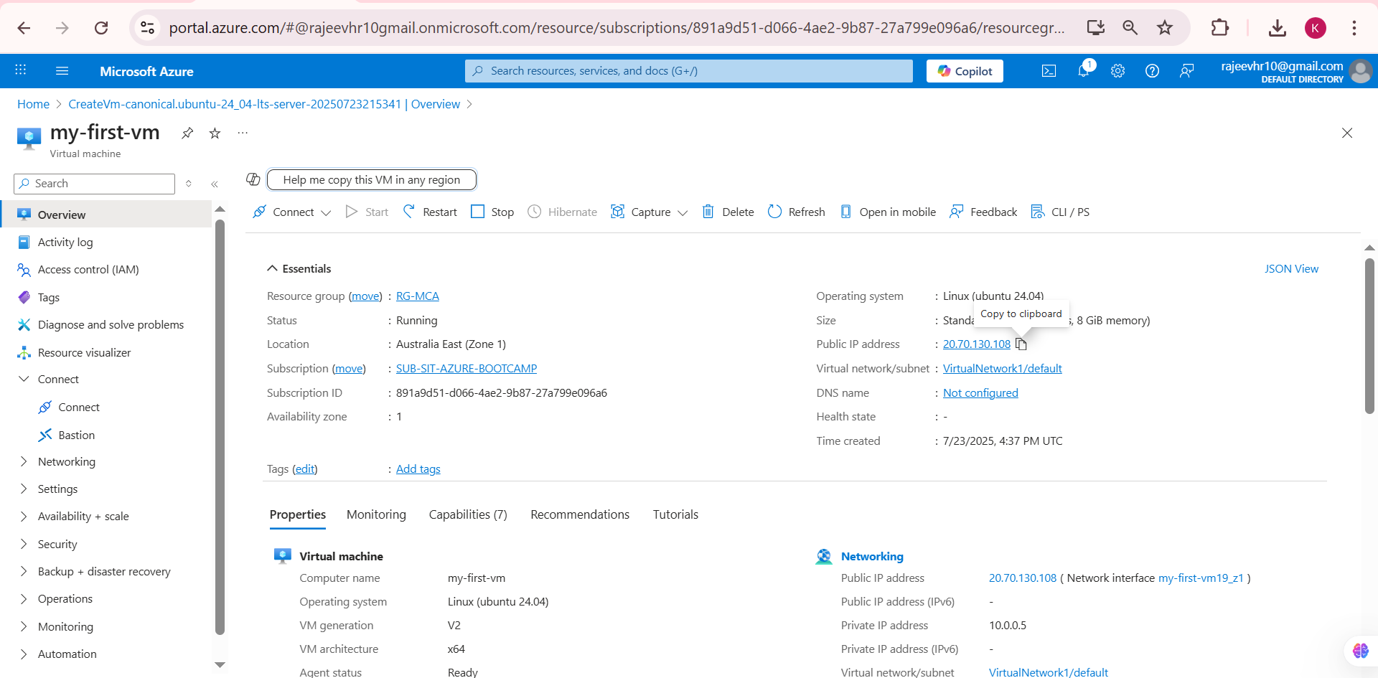

#### Step 15: Configure PuTTY Connection

1. Open PuTTY application
2. **Host Name**: Paste the copied public IP address
3. **Port**: 22 (default for SSH)
4. **Connection type**: SSH

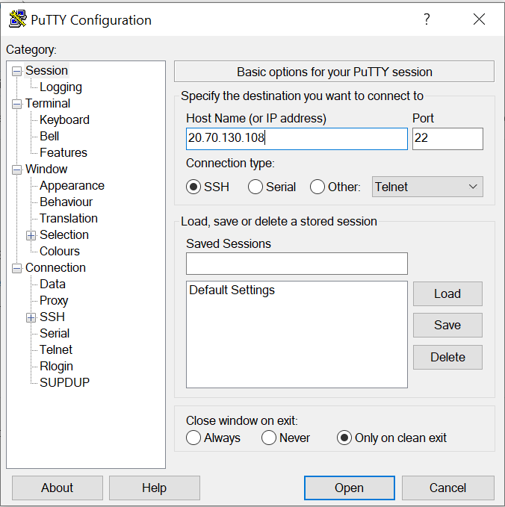

#### Step 16: Configure SSH Authentication

1. In the left panel, expand "SSH" → "Auth" → "Credentials"
2. Click "Browse" next to "Private key file for authentication"
3. Select the .ppk file you created earlier

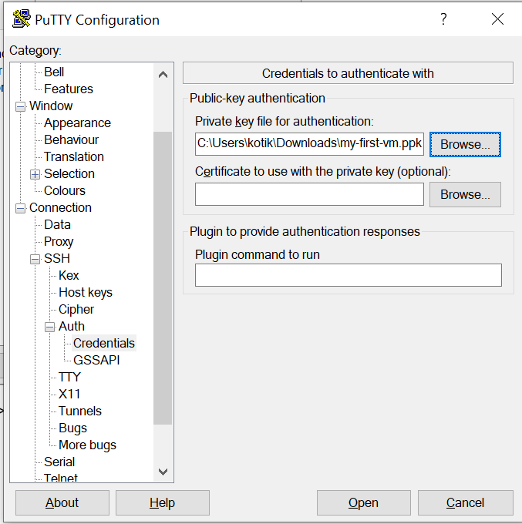

#### Step 17: Establish Connection

1. Click "Open" to connect
2. **Login as**: Enter your username (e.g., "azureuser")

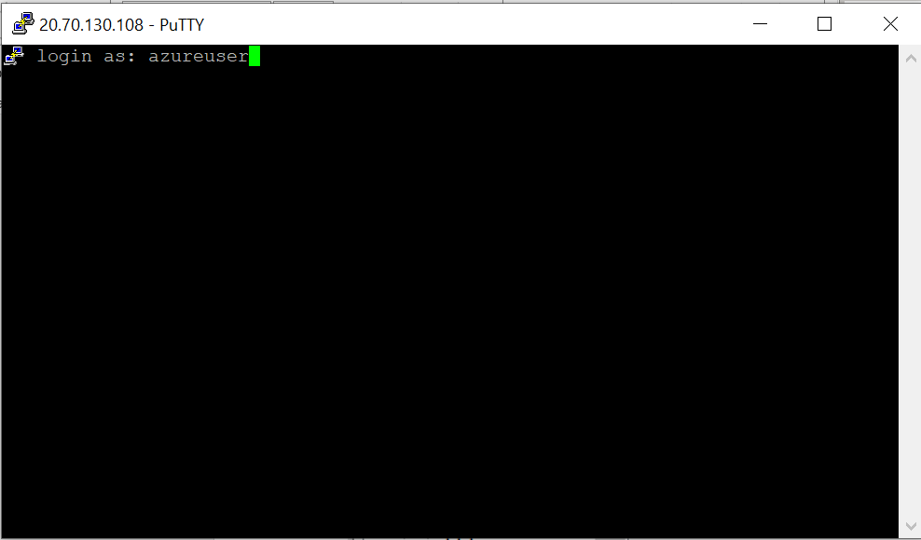

### Initial System Setup

#### Step 18: Switch to Root User

Once connected to your Ubuntu VM, run:

sudo su –

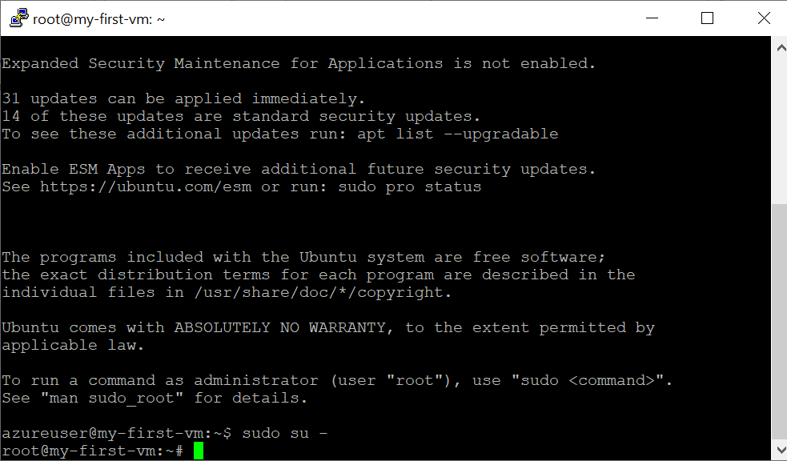

### Step 19: Update System Packages

### 

### Installing Apache and PHP

#### Step 20: Install Apache Web Server and PHP

sudo apt install -y apache2 php libapache2-mod-php

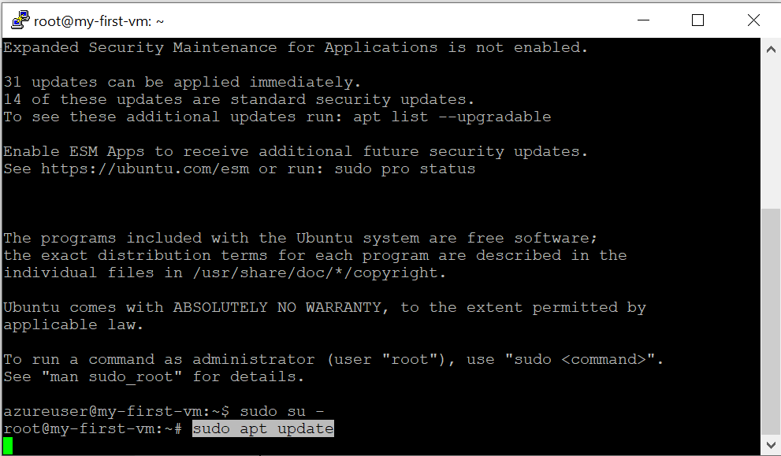

### Step 21: Verify PHP Installation

php –v

Expected output should show PHP version information.

### Creating and Testing PHP File

#### Step 22: Navigate to Web Root Directory

cd /var/www/html

### Step 23: Create PHP Info File

sudo nano info.php

#### Step 24: Add PHP Code

Type the following content in the nano editor:

<?php

phpinfo();

?>

#### Step 25: Save and Exit

* Press Ctrl + O to save
* Press Enter to confirm filename
* Press Ctrl + X to exit

#### Step 26: Restart Apache Service

sudo systemctl restart apache2

### Enabling HTTP Access (Port 80)

#### Step 27: Access Networking Settings

1. In Azure Portal, go to your VM
2. Click "Networking" from the left menu
3. Click "Network settings"

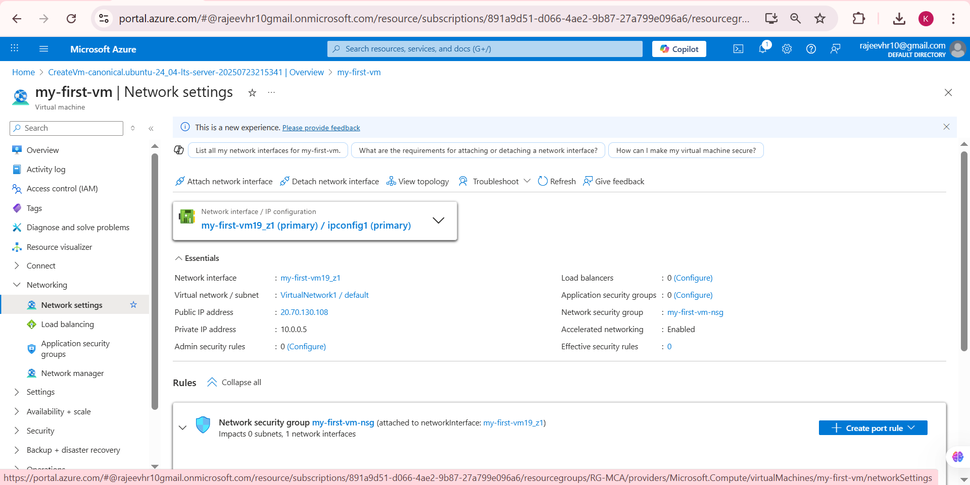

#### Step 28: Create Inbound Port Rule

1. Click "Create port rule"
2. Select "Inbound port rule"

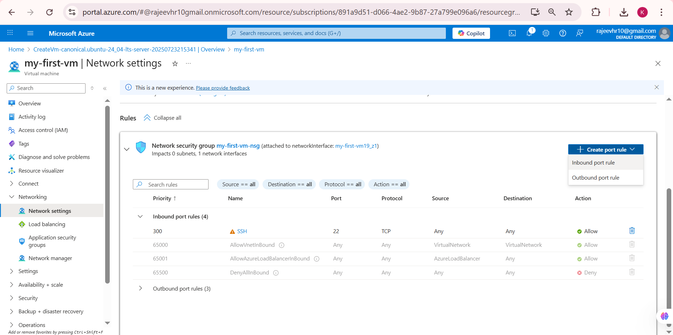

#### Step 29: Configure HTTP Rule

Fill in the following:

* **Service**: Select "HTTP"
* **Protocol**: TCP
* **Destination port ranges**: 80
* **Action**: Allow
* **Name**: HTTP-80

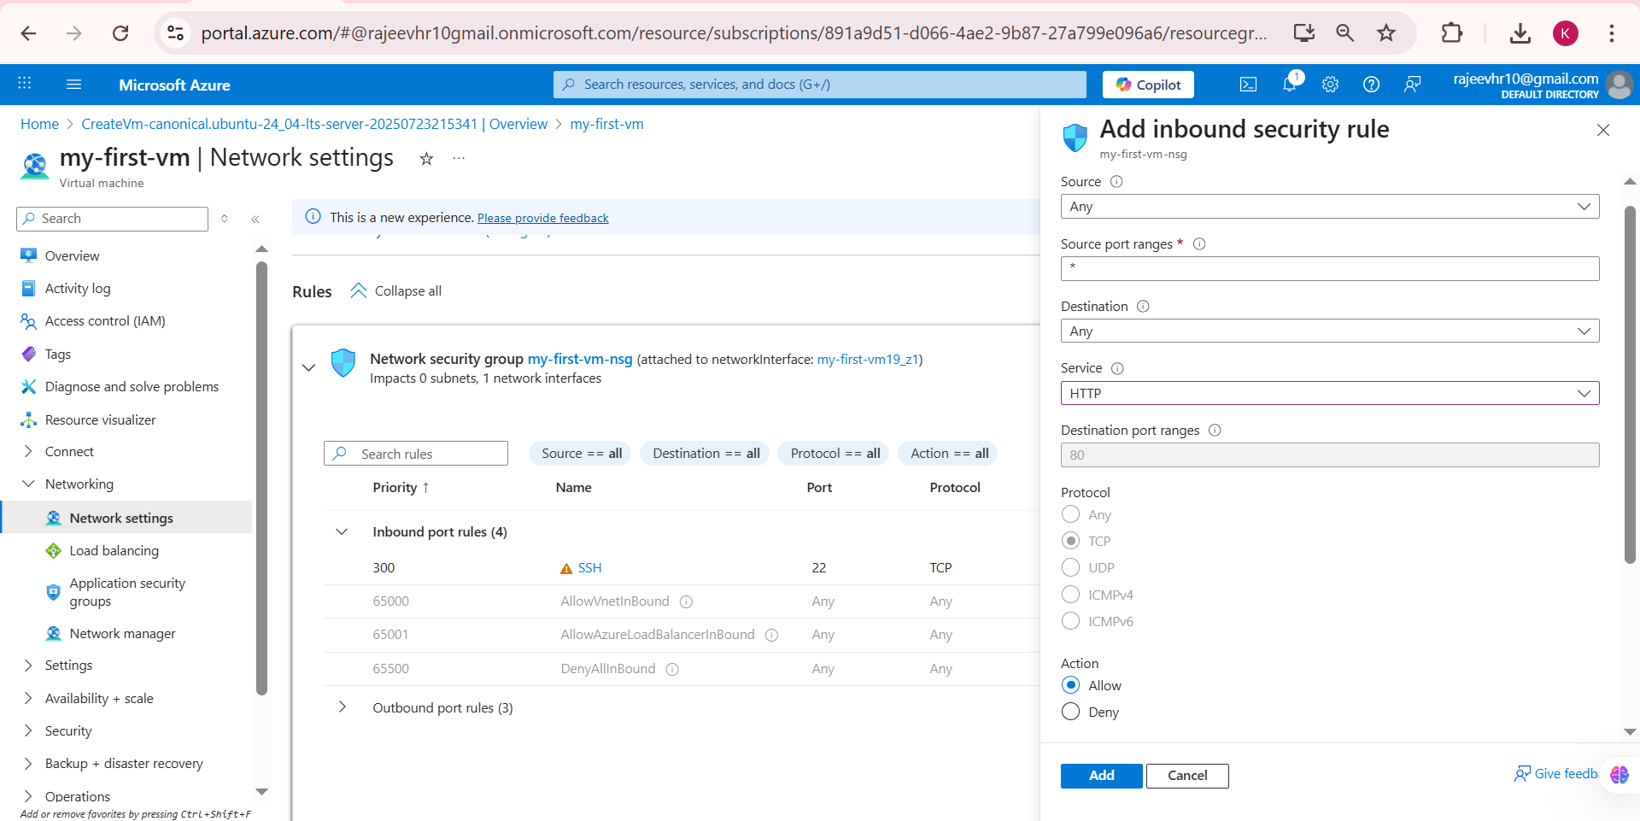

* Click "Add" to create the rule

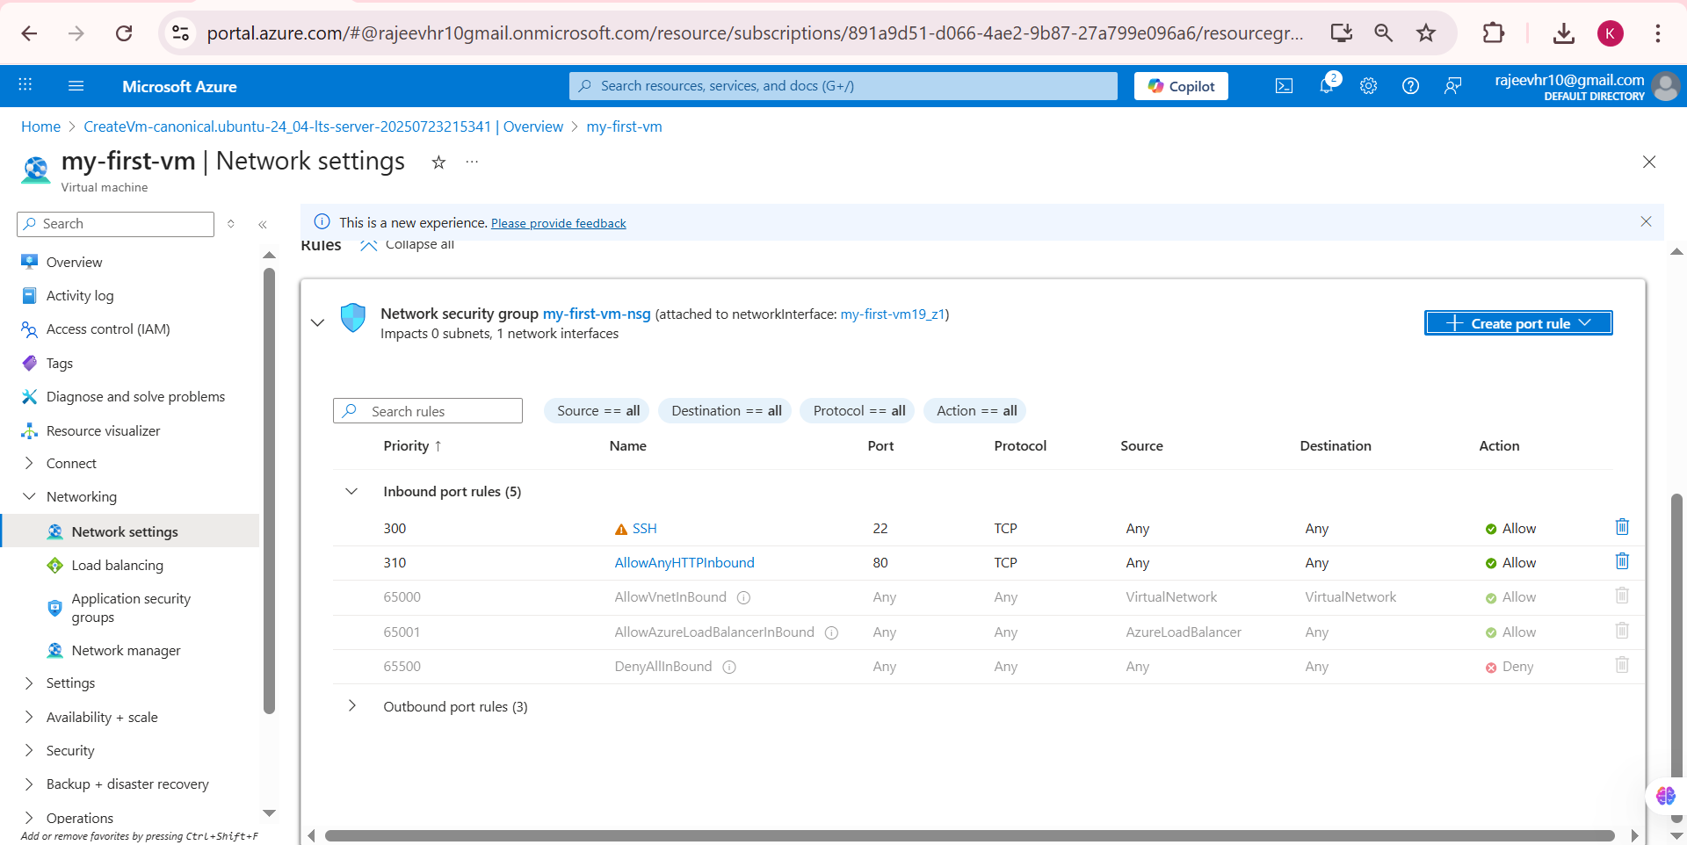

### Test Web Server

#### Step 30: Test Apache Default Page

1. Open a web browser
2. Navigate to: http://[YOUR-VM-PUBLIC-IP]/ [Ex: http://20.70.130.108/]
3. You should see the Apache2 default page

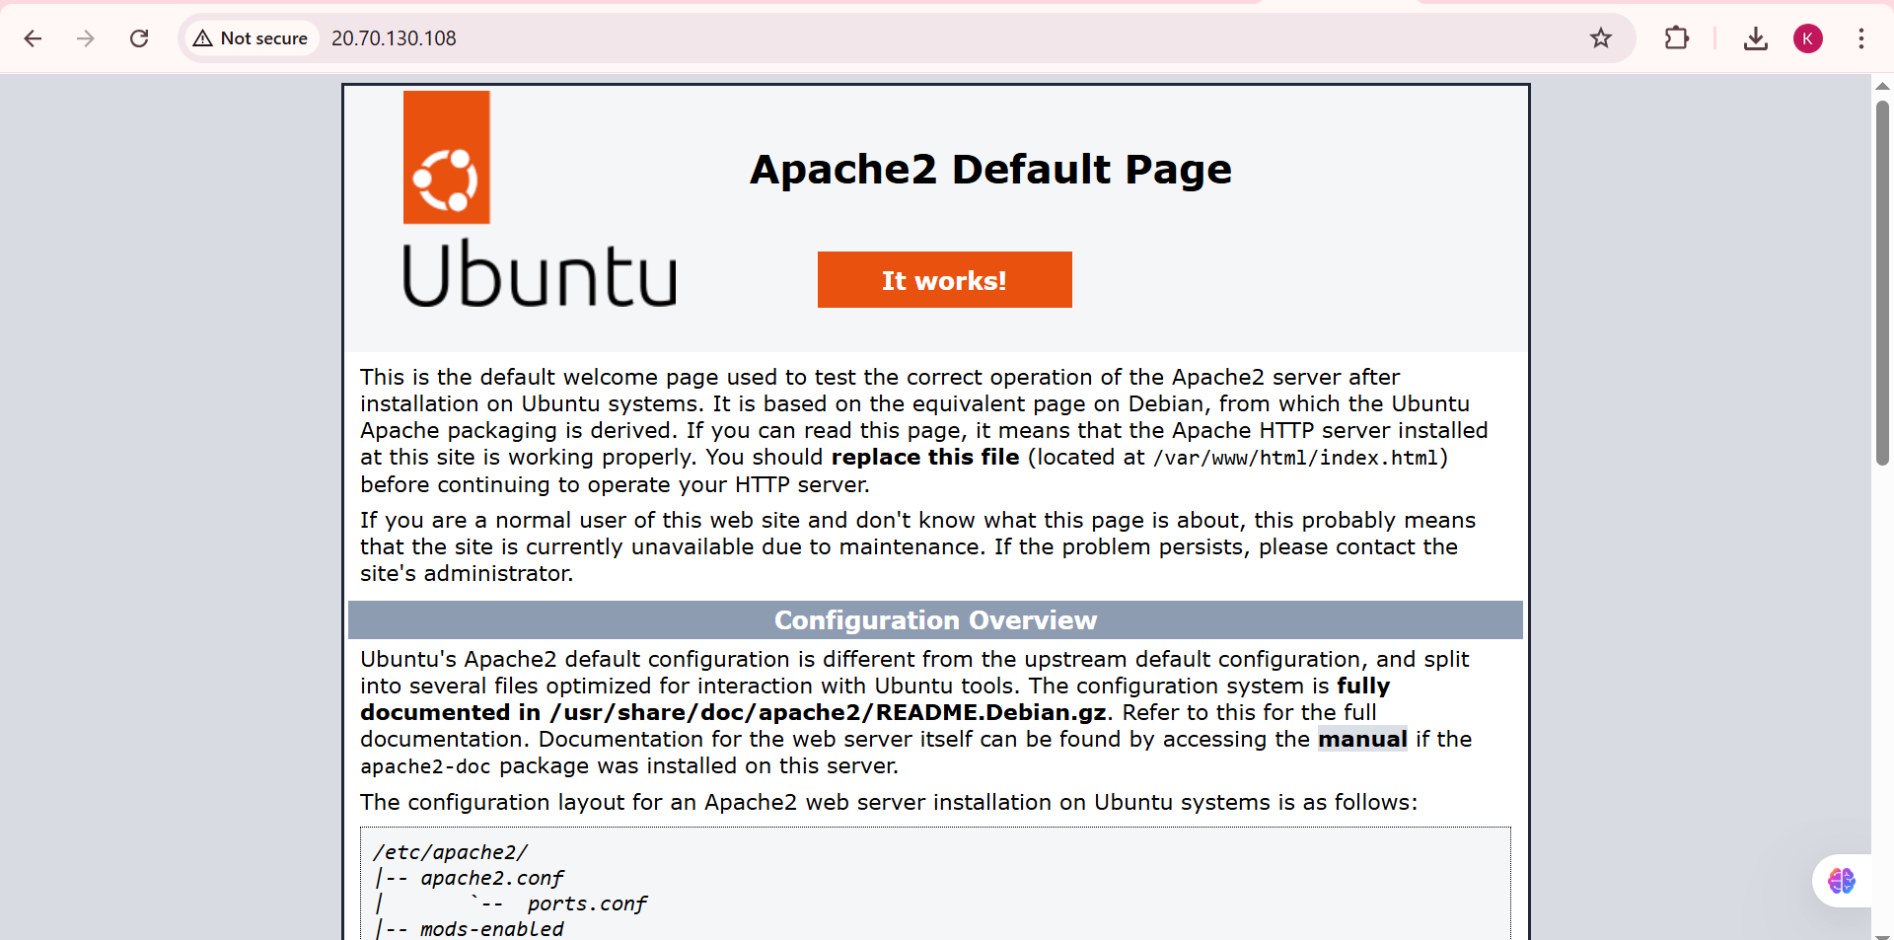

#### Step 31: Test PHP Configuration

1. Navigate to: http://[YOUR-VM-PUBLIC-IP]/info.php
2. You should see the PHP information page with configuration details

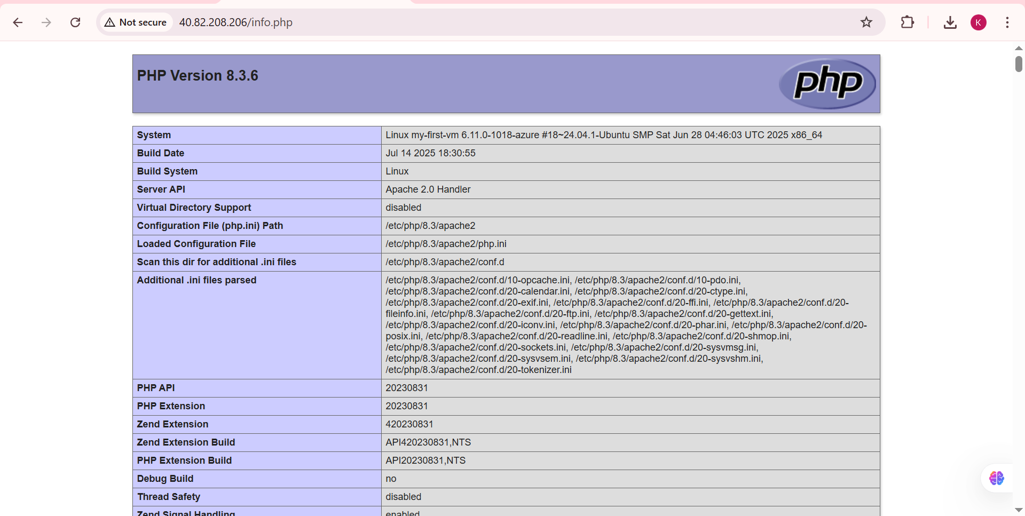

## Accessing Ubuntu VM using FileZilla

## Downloading and Installing FileZilla

#### Access FileZilla Website

1. Open your web browser
2. Navigate to the official FileZilla website: <https://filezilla-project.org/>

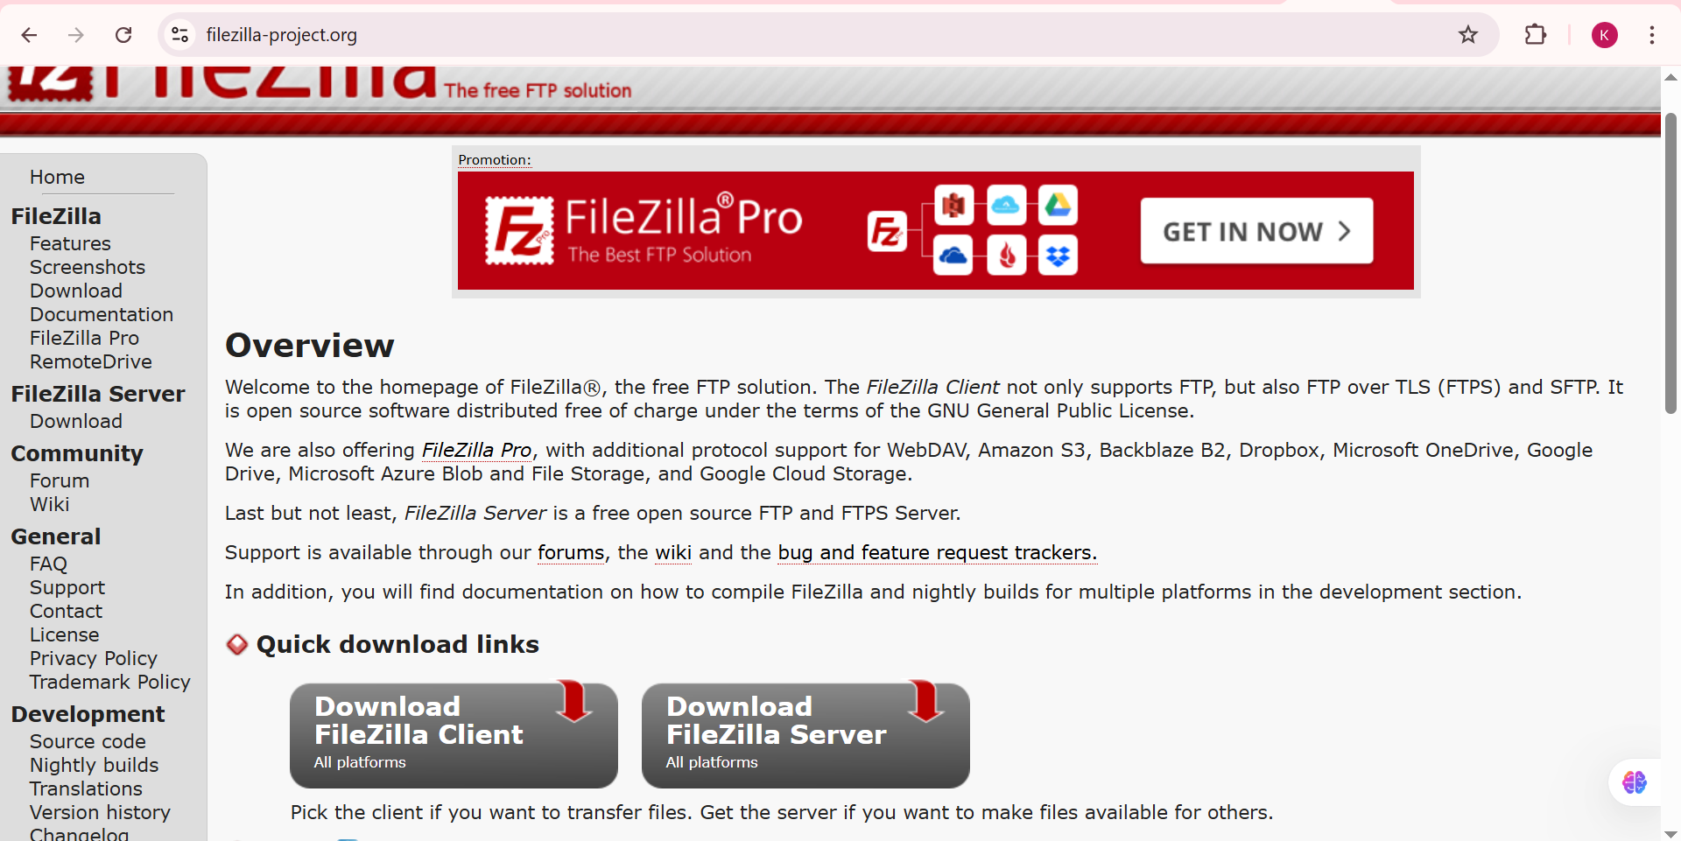

### Download FileZilla Client

1. Click on "Download FileZilla Client" button
2. The website will automatically detect your operating system

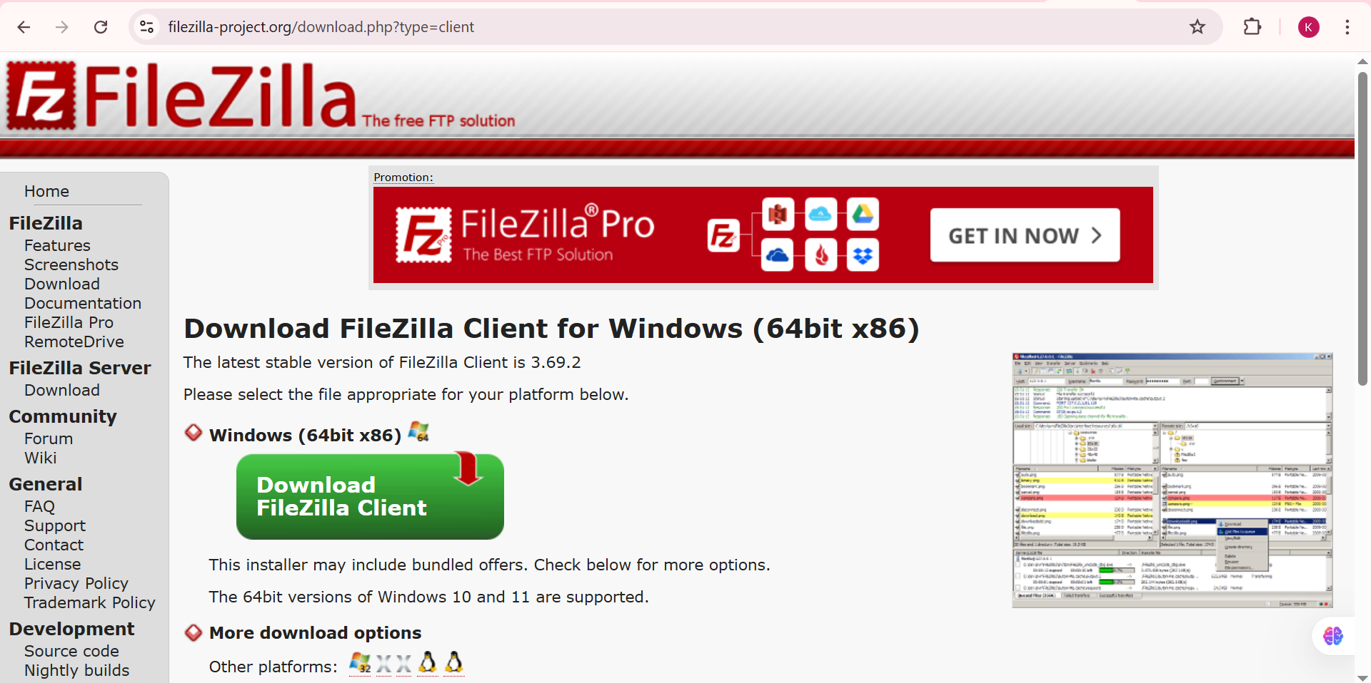

* Click "Download" to begin downloading the installer

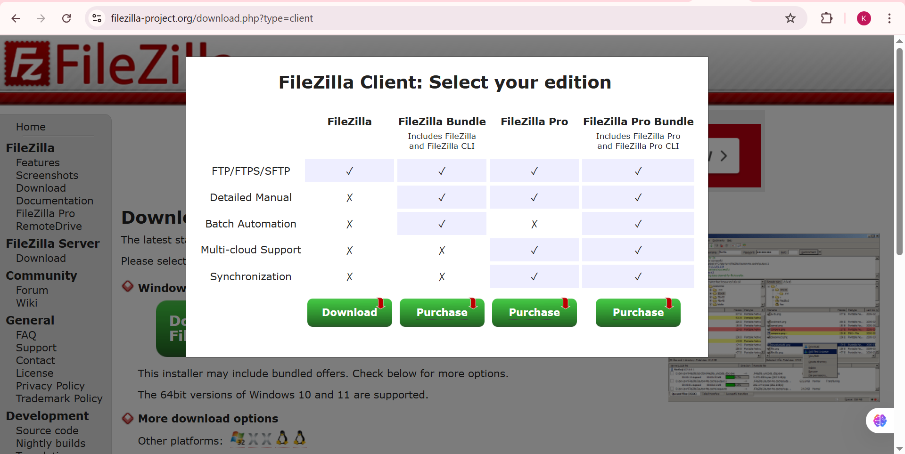

### Run the Installer

1. Locate the downloaded installer file (usually in Downloads folder)
2. Double-click the installer to run it
3. If prompted by Windows Security, click "Yes" to allow the installation

### Accept License Agreement

1. Read the license agreement
2. Click "I Agree" to accept the terms and conditions

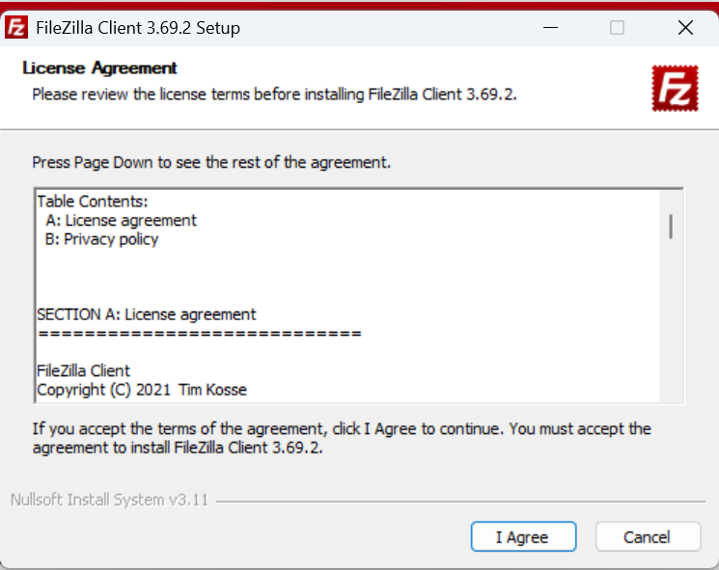

* Select "Accept" and click "Next" to continue

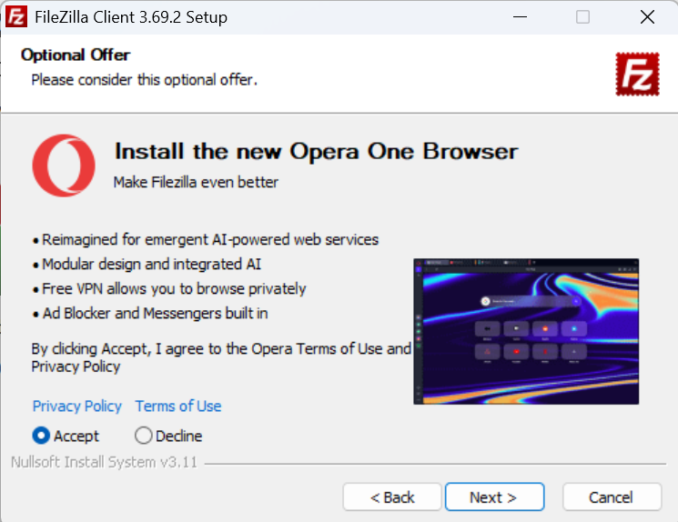

* Select "Standard" installation (recommended for most users)
* Click "Next" to continue

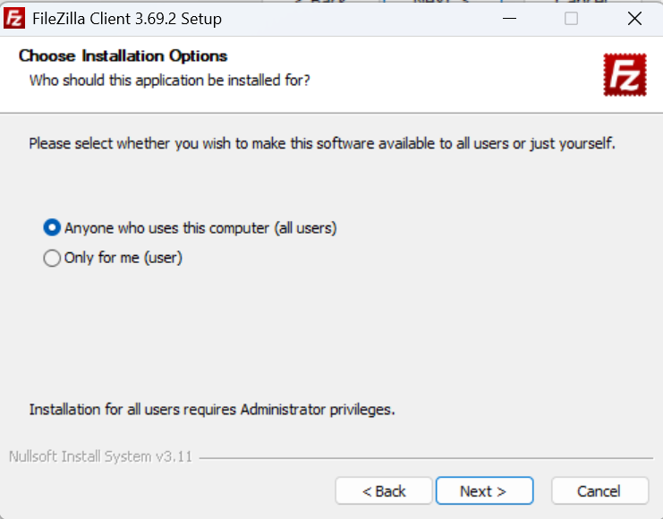

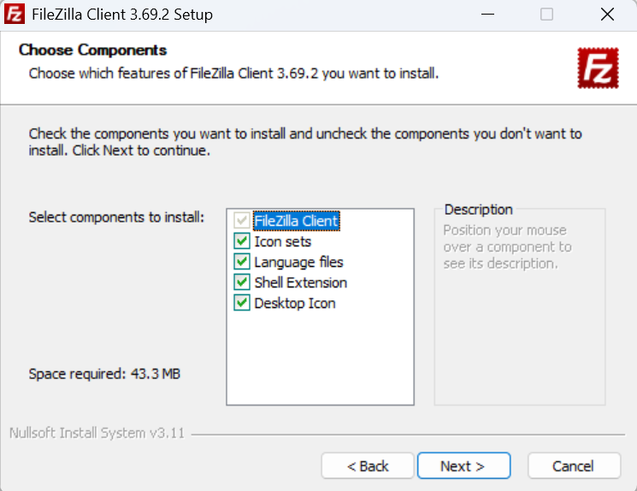

* Choose the installation directory (default is usually fine)
* Click "Next" to proceed

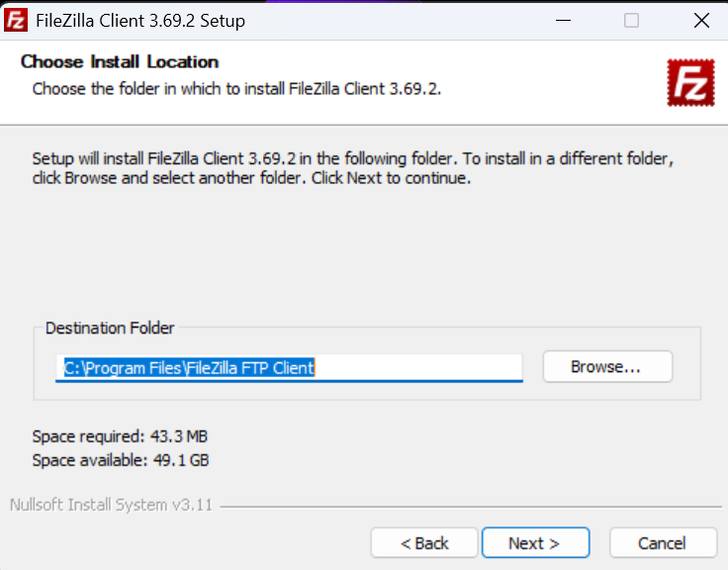

* Select or create a Start Menu folder for FileZilla shortcuts
* Click "Install" to begin the installation process

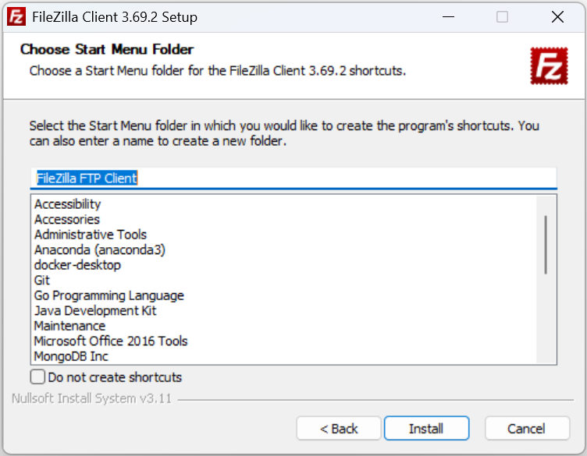

* Wait for the installation to complete
* The progress bar will show installation status
* Uncheck "Start FileZilla now" if you want to configure it later
* Click "Finish" to complete the installation

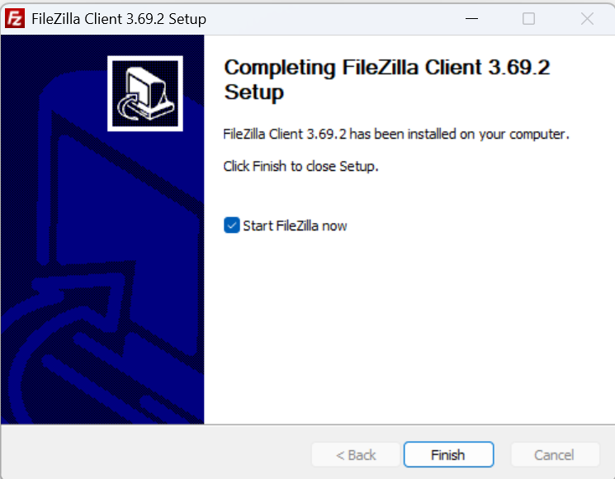

* Launch FileZilla application
* Go to **File** → **Site Manager** (or press Ctrl+S)

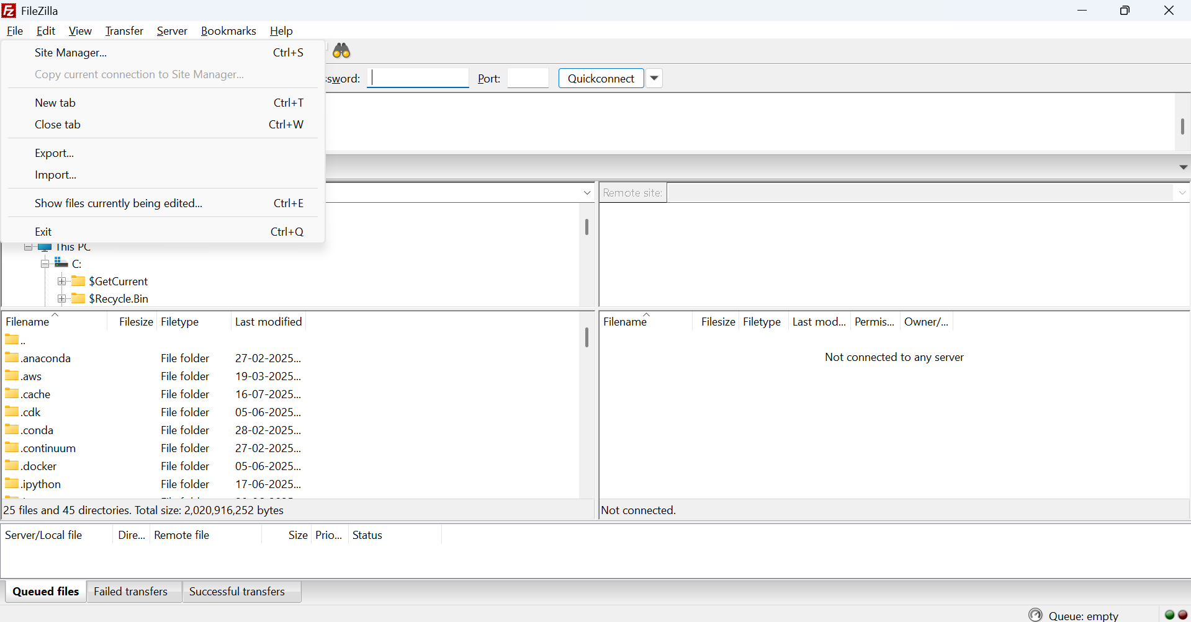

* In the Site Manager dialog, click "New Site" button
* A new site entry will be created in the left panel

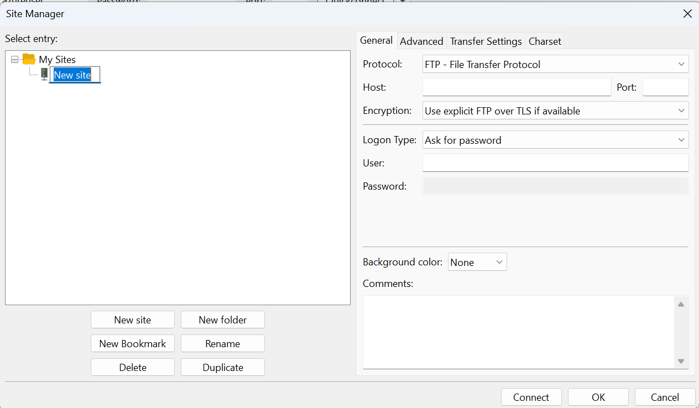

* Replace "New site" with a descriptive name (e.g., "Ubuntu-Azure-VM")
* This name will help you identify the connection later
* In the **Protocol** dropdown, select **SFTP - SSH File Transfer Protocol**

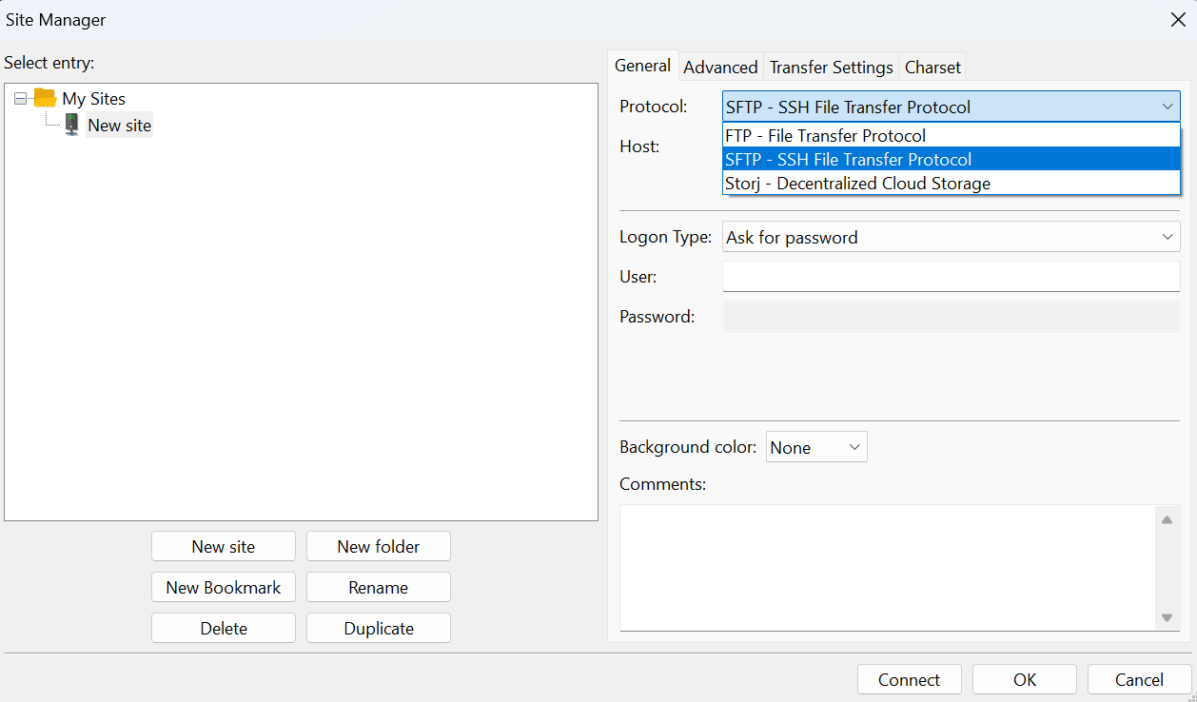

### Enter Host Information

* **Host**: Enter your Ubuntu VM's public IP address
  + Example: 20.70.130.108 (use your actual VM IP)
* **Port**: Leave as default 22 (standard SSH/SFTP port)
* **Logon Type**: Select "Key file" from the dropdown
* • This enables SSH key-based authentication

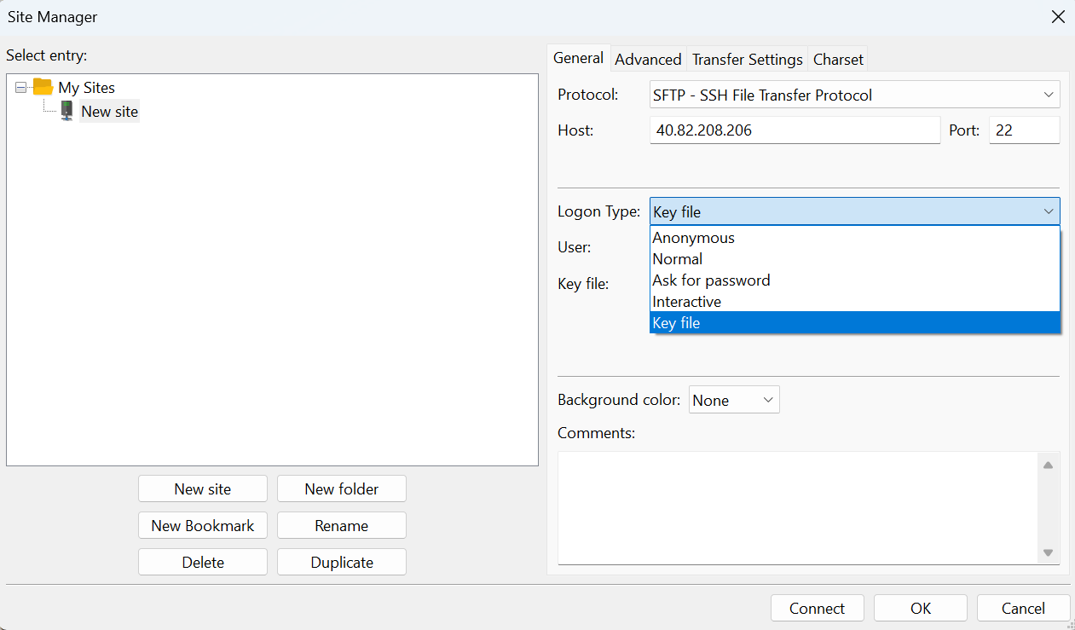

* **User**: Enter your VM username (typically "azureuser")
* Click the **Browse** button next to "Key file"
* Navigate to the location where you saved your .ppk file
* Select your private key file (.ppk format)
* Click "Open"
* Click "Connect" to establish connection to your Ubuntu VM

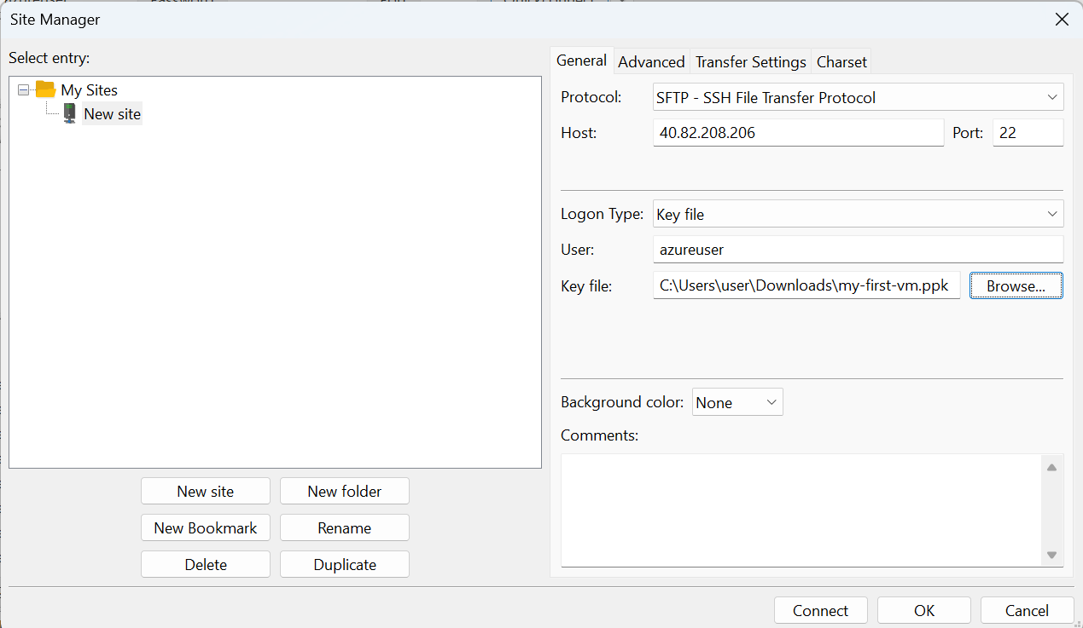

* On first connection, you'll see a host key verification dialog
* Click "OK" to accept and remember the host key

Once connected, you'll see:

* **Left Panel**: Your local computer's file system
* **Right Panel**: Your Ubuntu VM's file system
* **Status Window**: Connection messages and transfer logs

### Basic FileZilla Operations:

#### Uploading Files to Ubuntu VM:

1. Navigate to desired local folder in left panel
2. Navigate to target remote folder in right panel (e.g., /home/azureuser/)
3. Drag and drop files from left to right panel
4. Or right-click local file → "Upload"

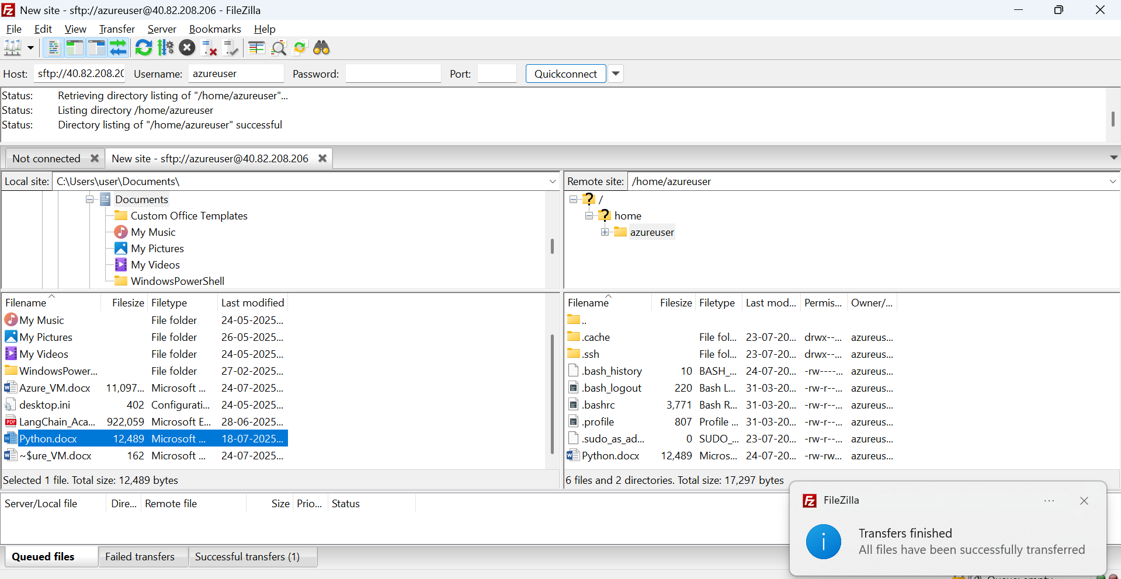

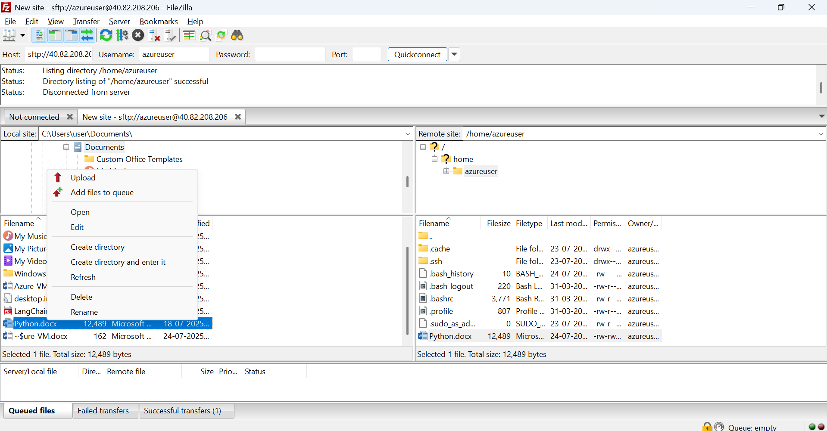

#### Downloading Files from Ubuntu VM:

1. Navigate to remote folder containing desired files
2. Navigate to target local folder
3. Drag and drop files from right to left panel
4. Or right-click remote file → "Download"

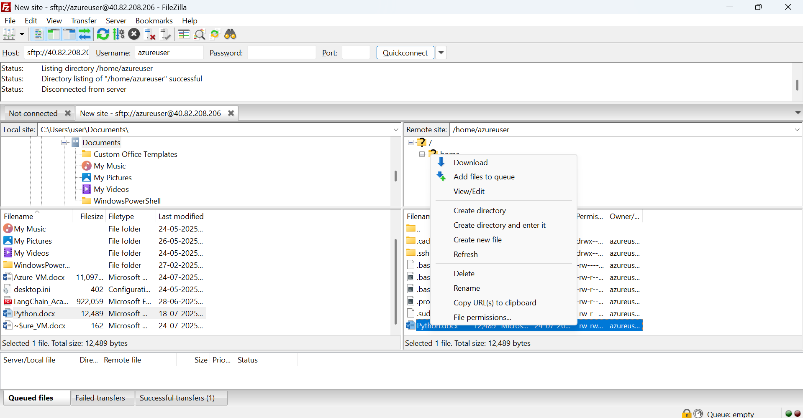

## 3. Windows Virtual Machine Setup

### Creating a Windows Virtual Machine

#### Step 33: Start New VM Creation

1. In Azure Portal, go to "Virtual machines"
2. Click "+ Create" → "Azure virtual machine"

#### Step 34: Configure Basic Settings

Fill in the following information:

* **Resource Group**: Use existing or create new
* **Virtual machine name**: Enter descriptive name (e.g., "Windows-Lab-VM")
* **Region**: Select appropriate region
* **Image**: Select "Windows Server 2022 Datacenter; Azure Edition – x64 Gen2”

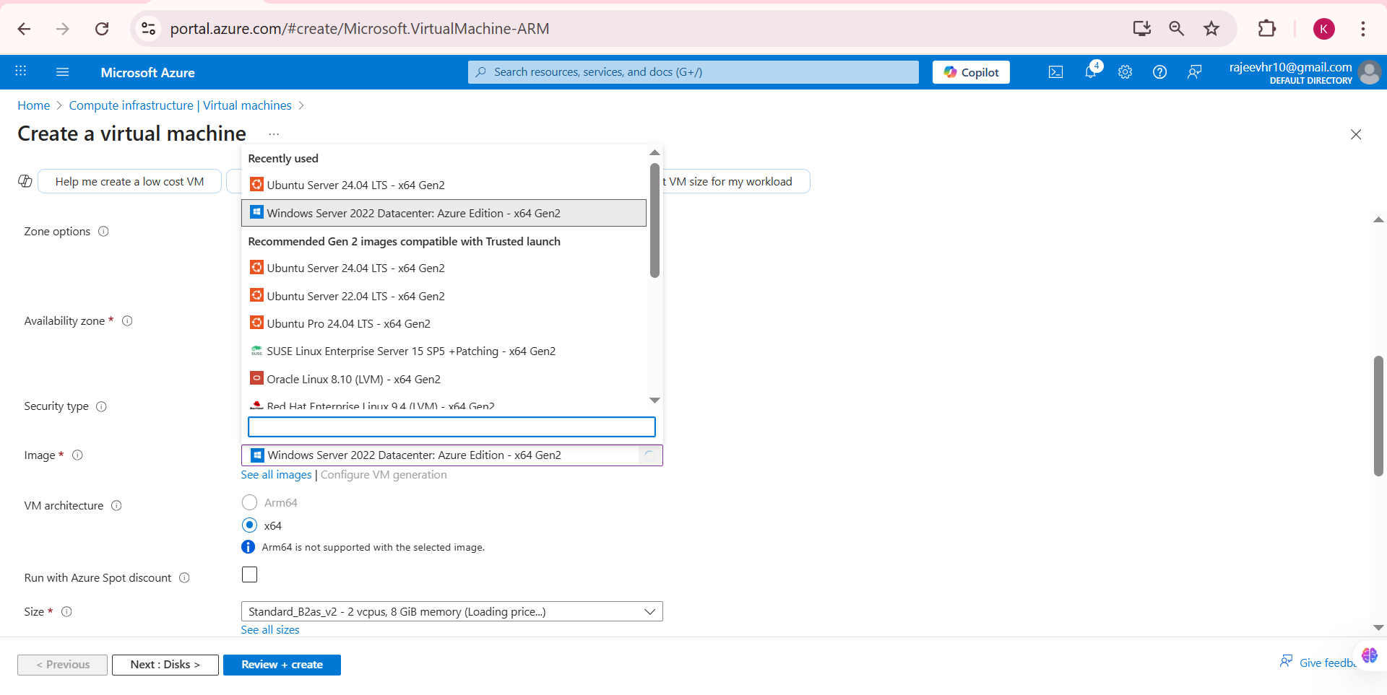

#### Step 35: Configure Size and Authentication

* **Size**: Choose "Standard_B2s" (2 vCPUs, 8 GB RAM) for Windows
* **Username**: Create administrator username
* **Password**: Set strong password (remember this!)
* **Confirm password**: Re-enter password

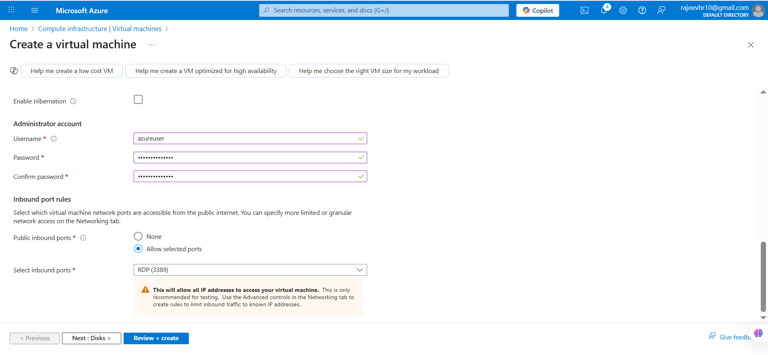

#### Step 36: Configure Inbound Ports

* **Public inbound ports**: Allow selected ports
* **Select inbound ports**: Choose "RDP (3389)" and "HTTP (80)"
* Click "Review + create"
* Wait for deployment to complete.

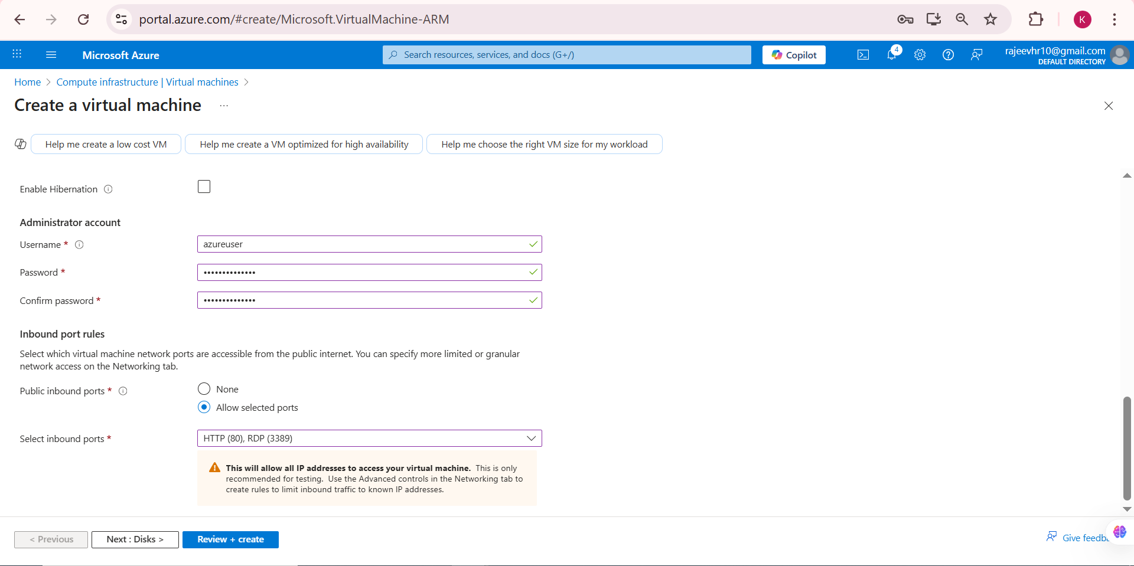

### Connecting to Windows VM via RDP

#### Step 38: Access Connection Settings

1. Go to your Windows and Select "RDP"

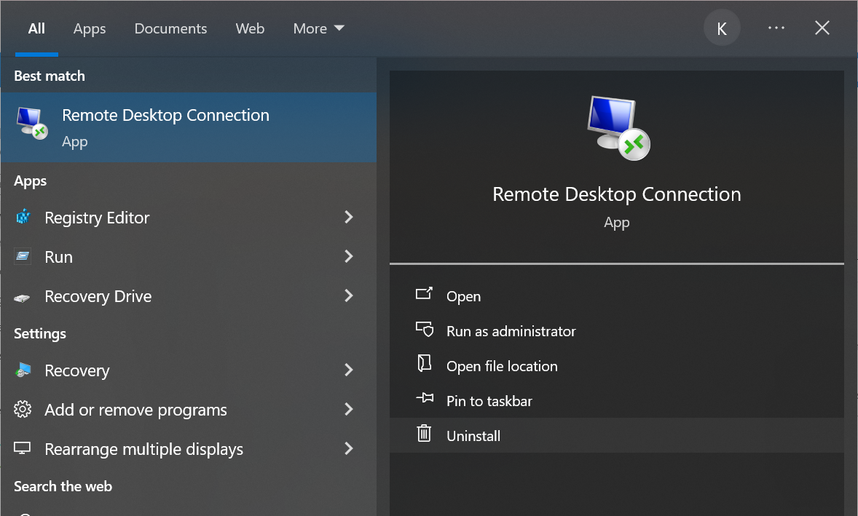

#### Step 39: Get Connection Details

* Note the Public IP address and user name
* Click "Connect"
* Enter your credentials

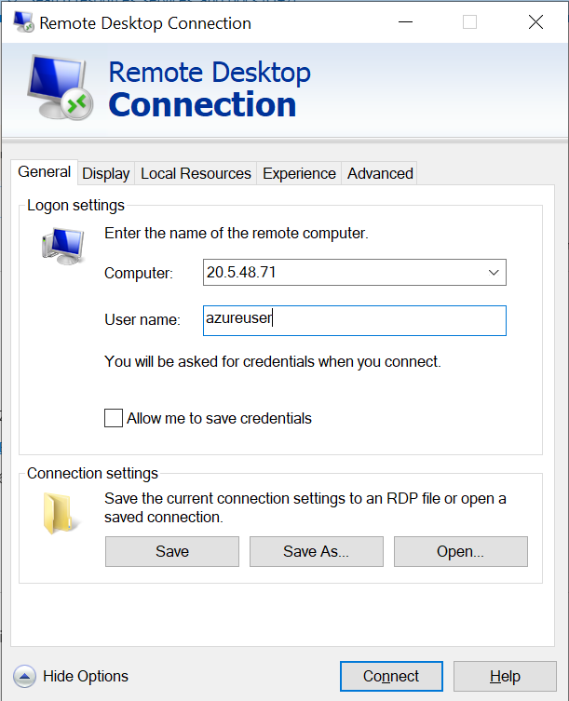

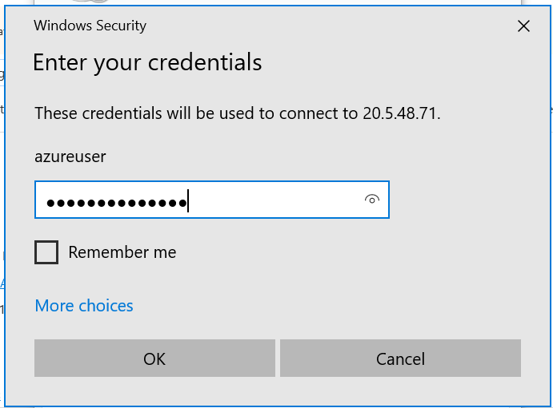

* You should now be connected to your Windows VM desktop

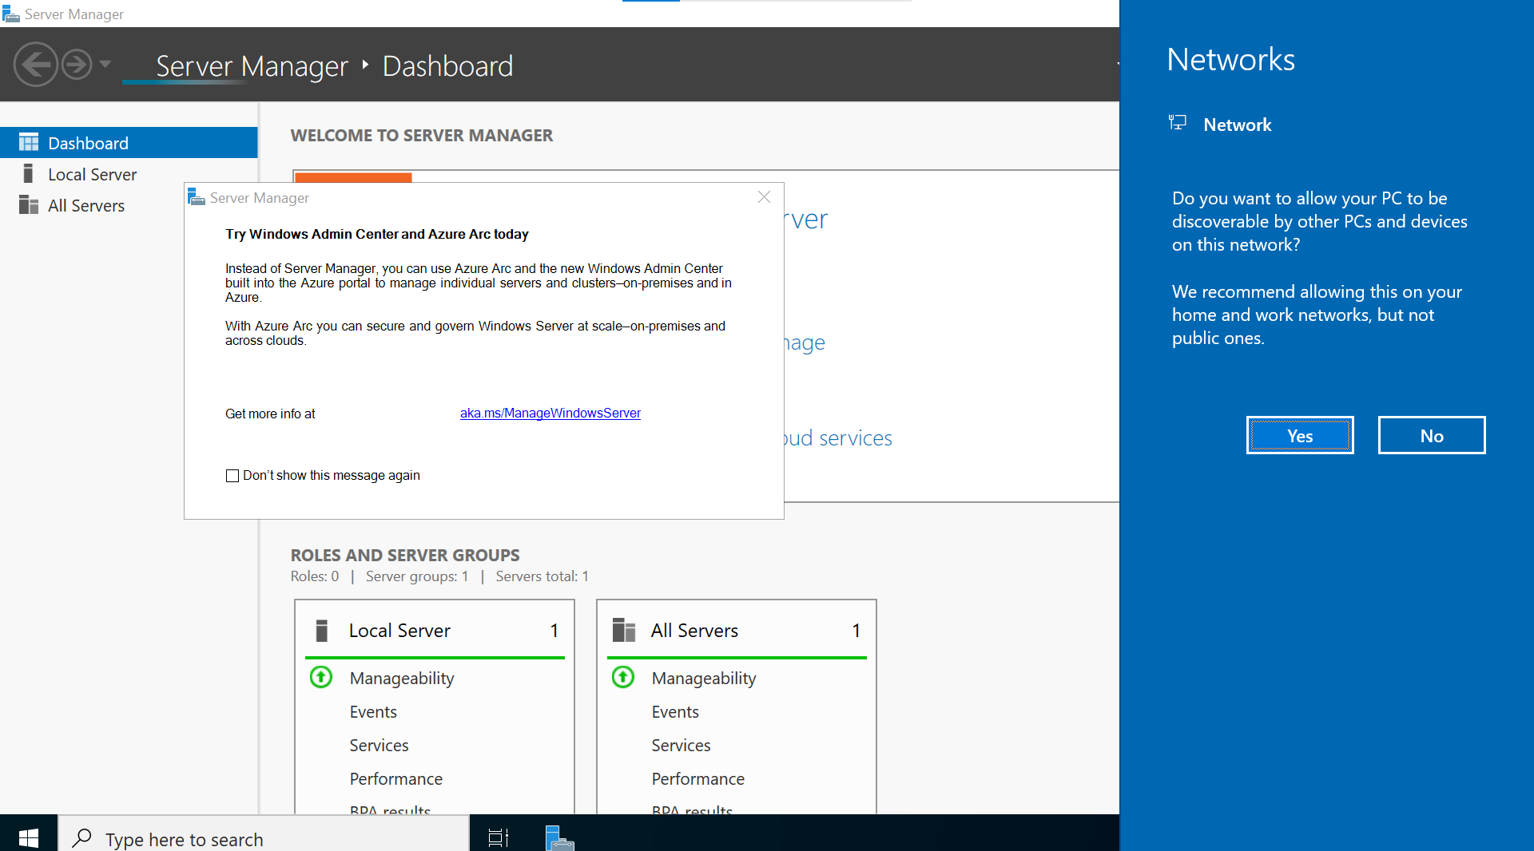

### Installing XAMPP

#### Step 41: Download XAMPP

1. Open web browser in your Windows VM
2. Navigate to: <https://www.apachefriends.org/index.html>
3. Click "Download" for Windows version

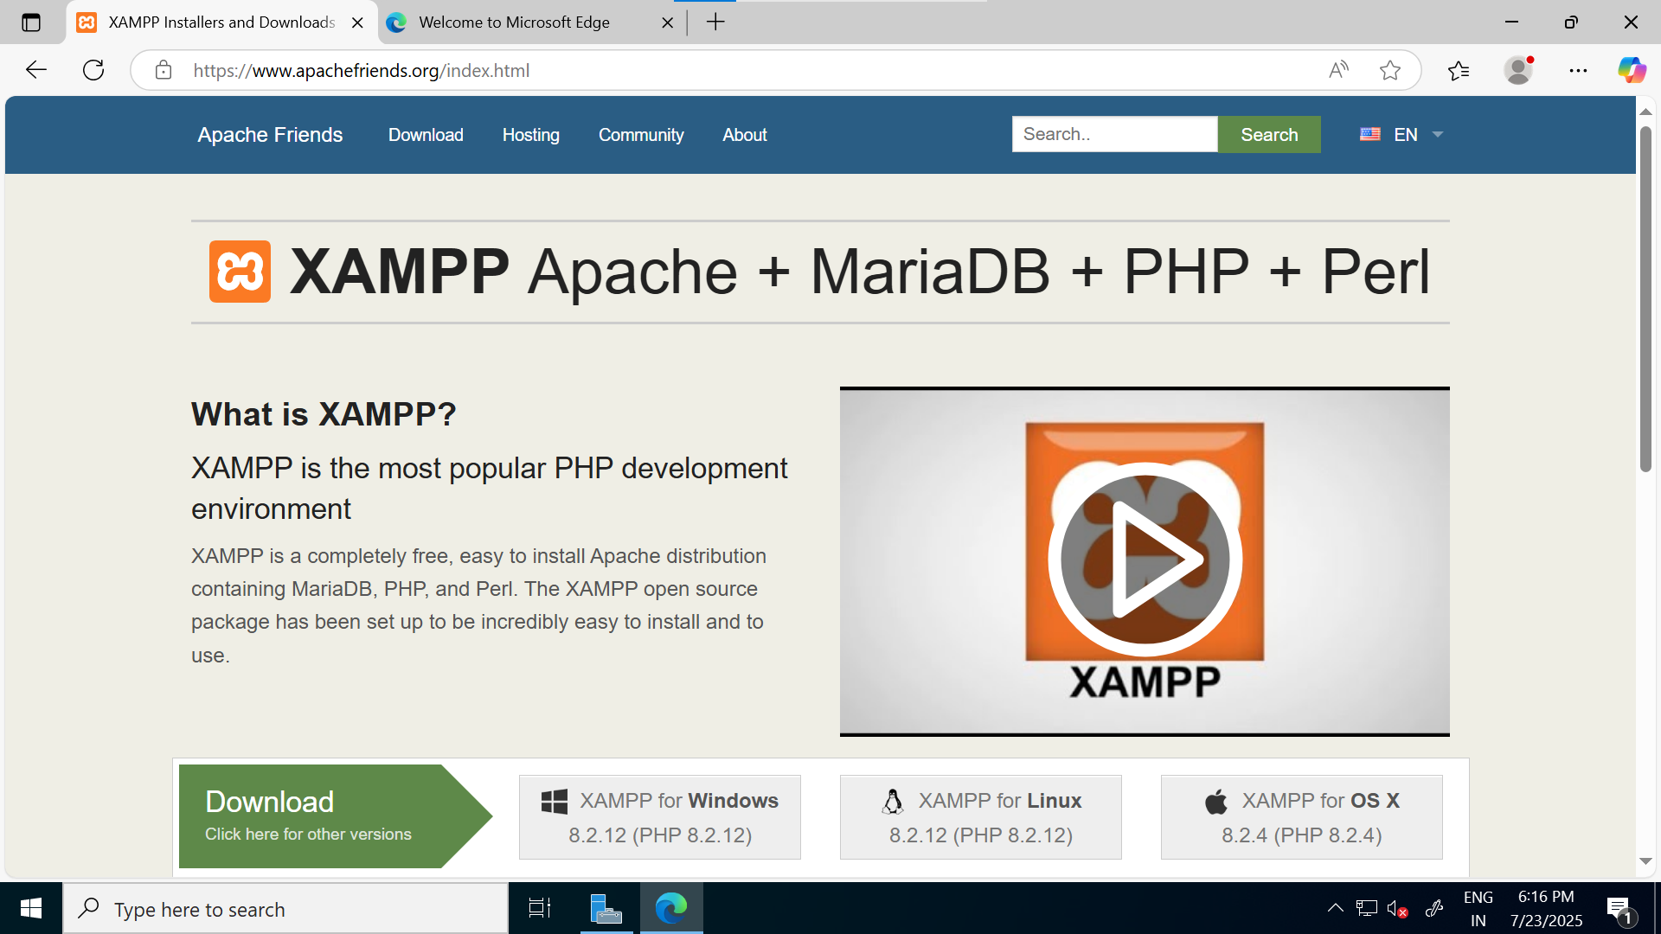

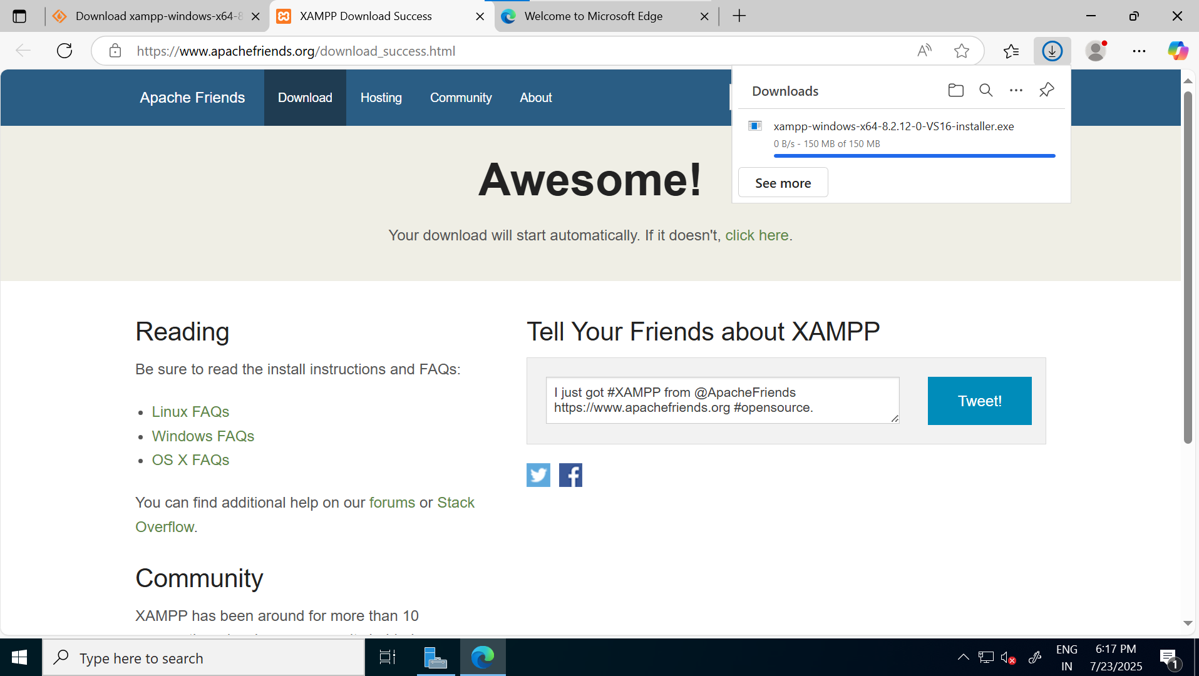

* Click on “Next” button.

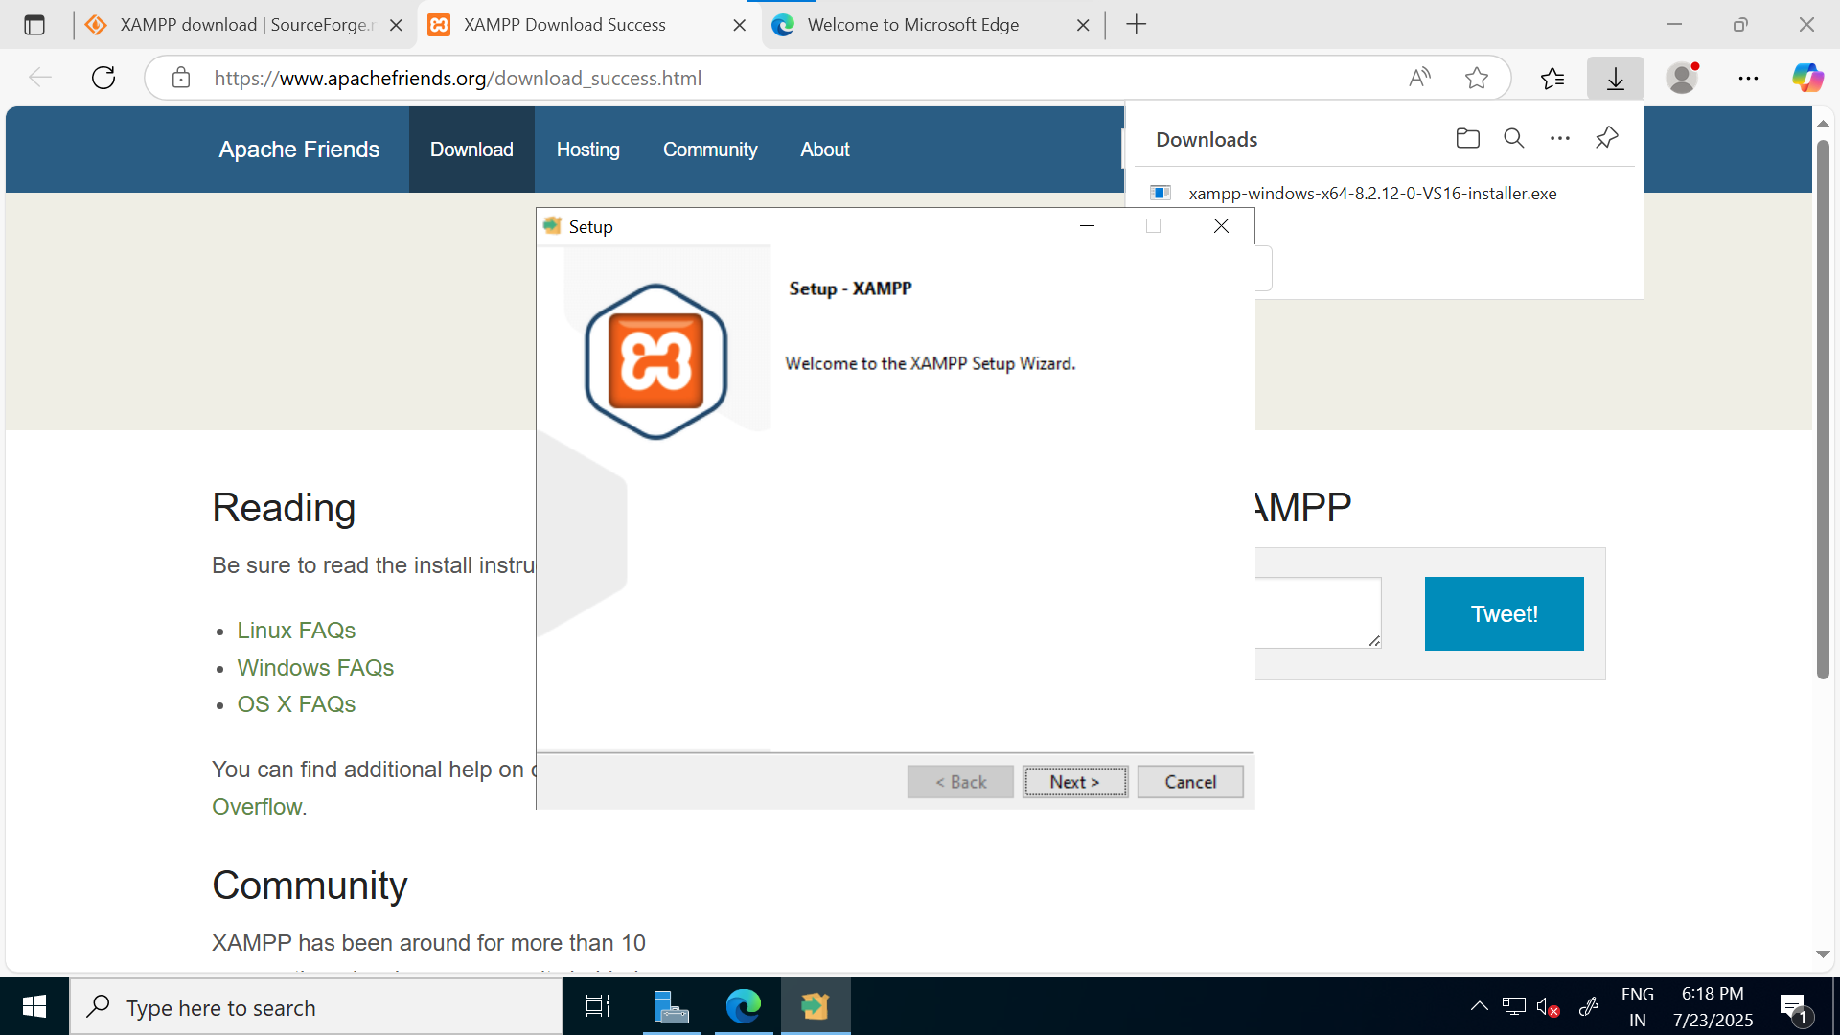

* Click on “Next” button.

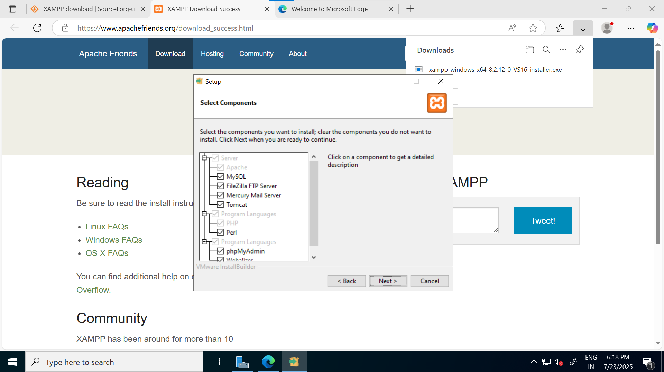

* Click on “Next” button.

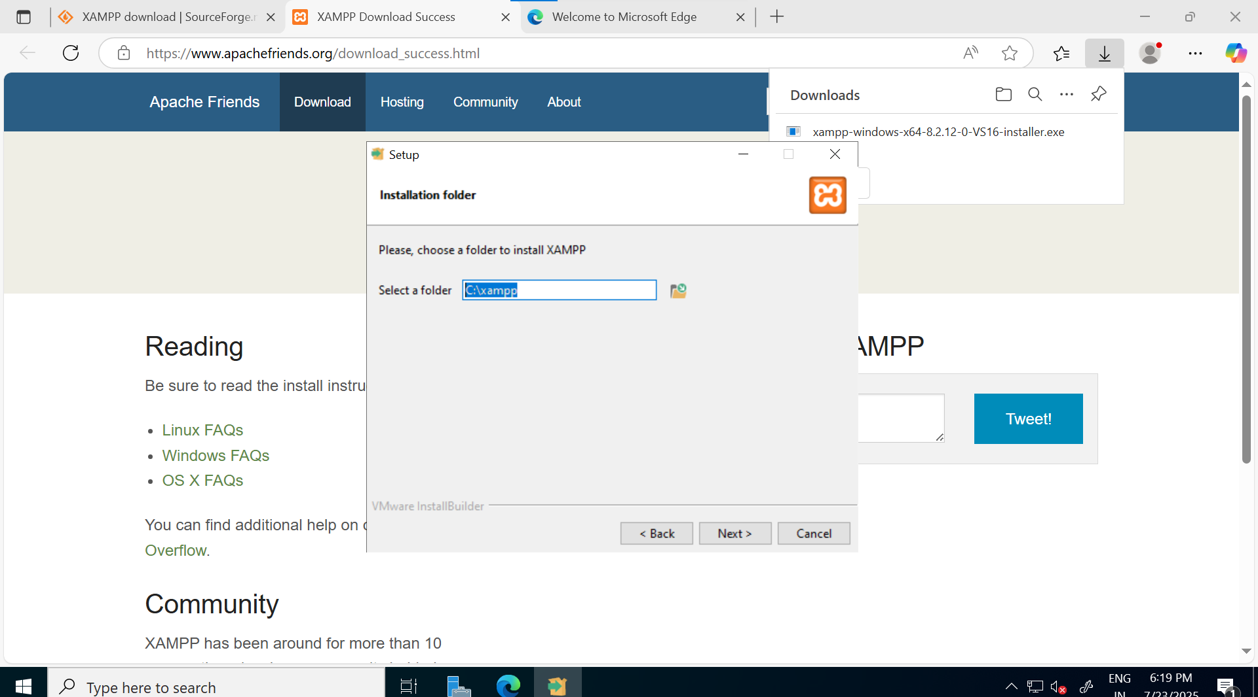

* Click on “Next” button.

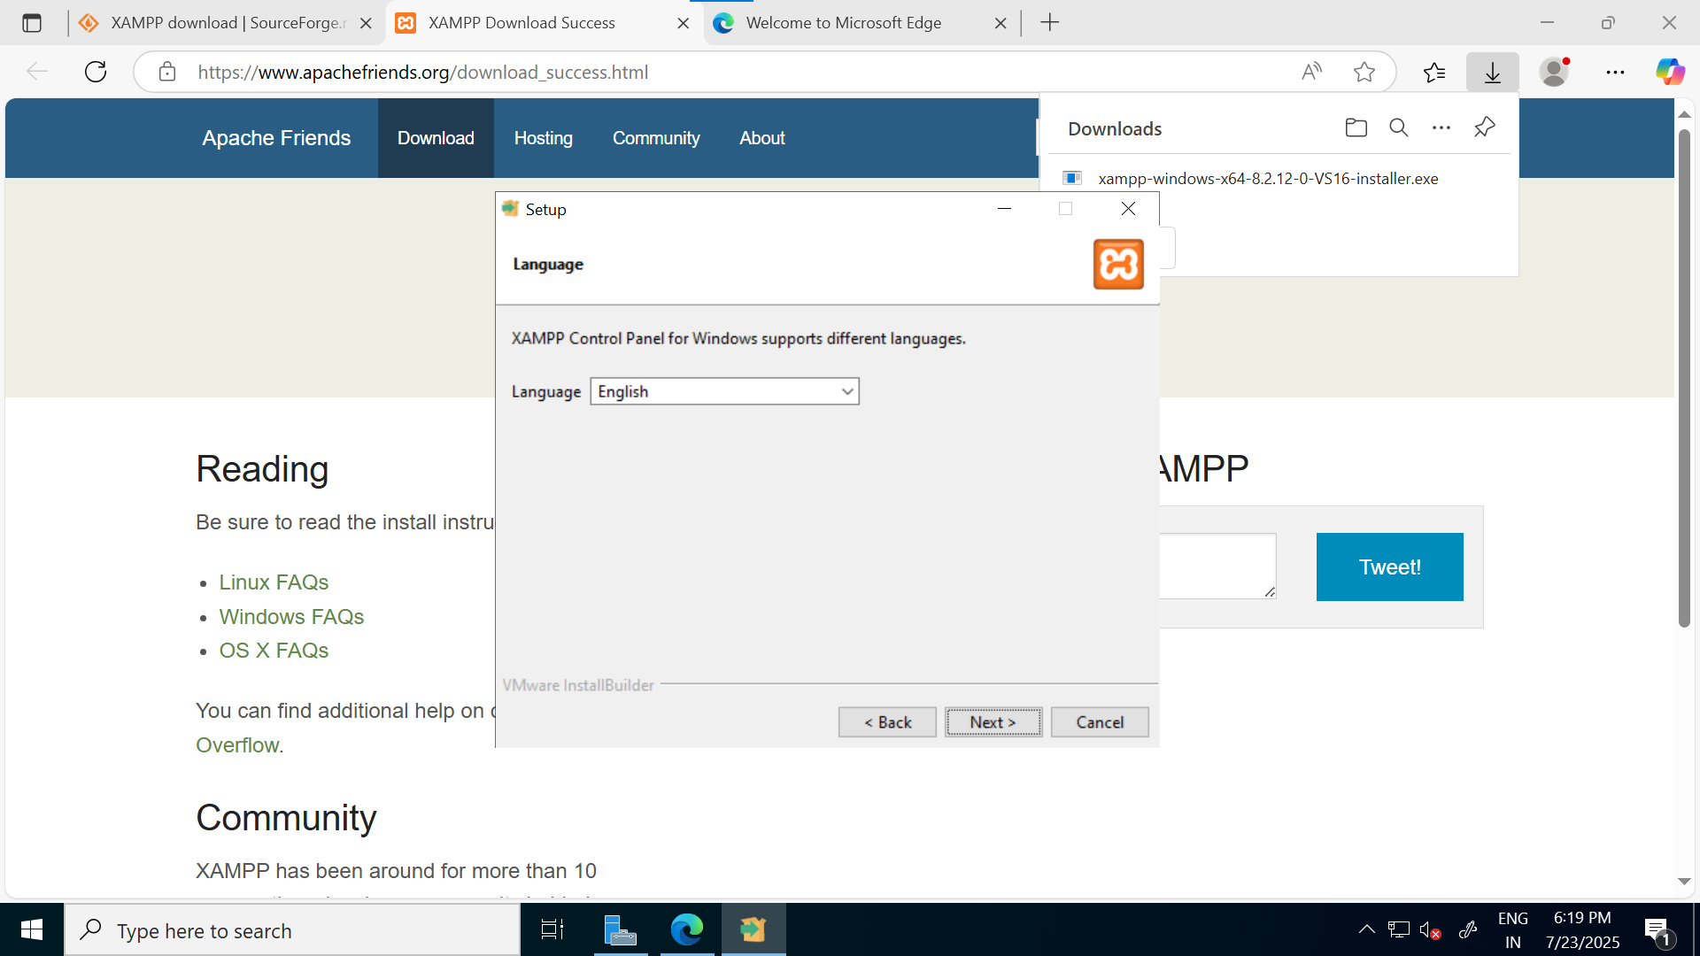

* Click on “Next” button.

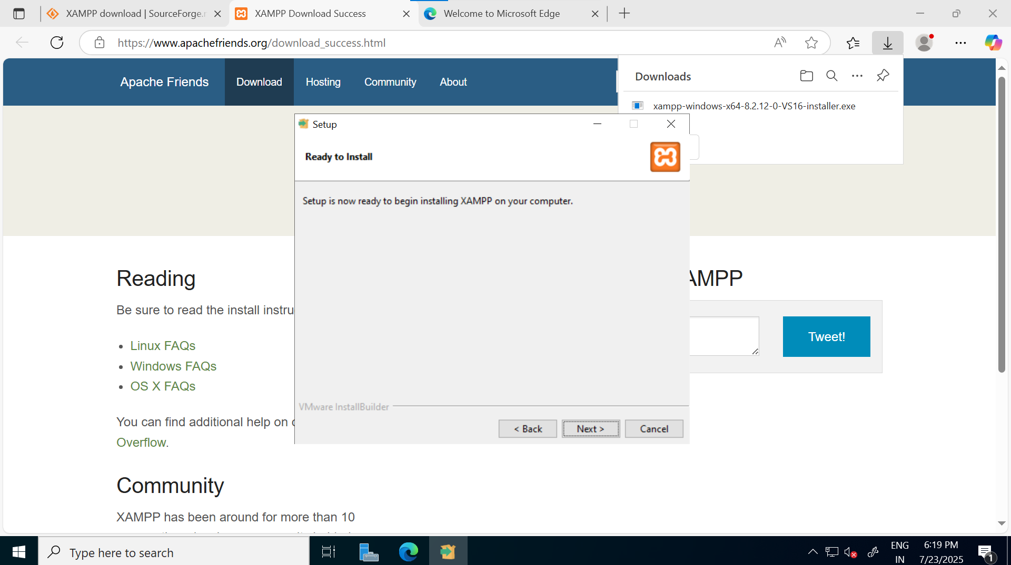

* Click on “Finish” button.

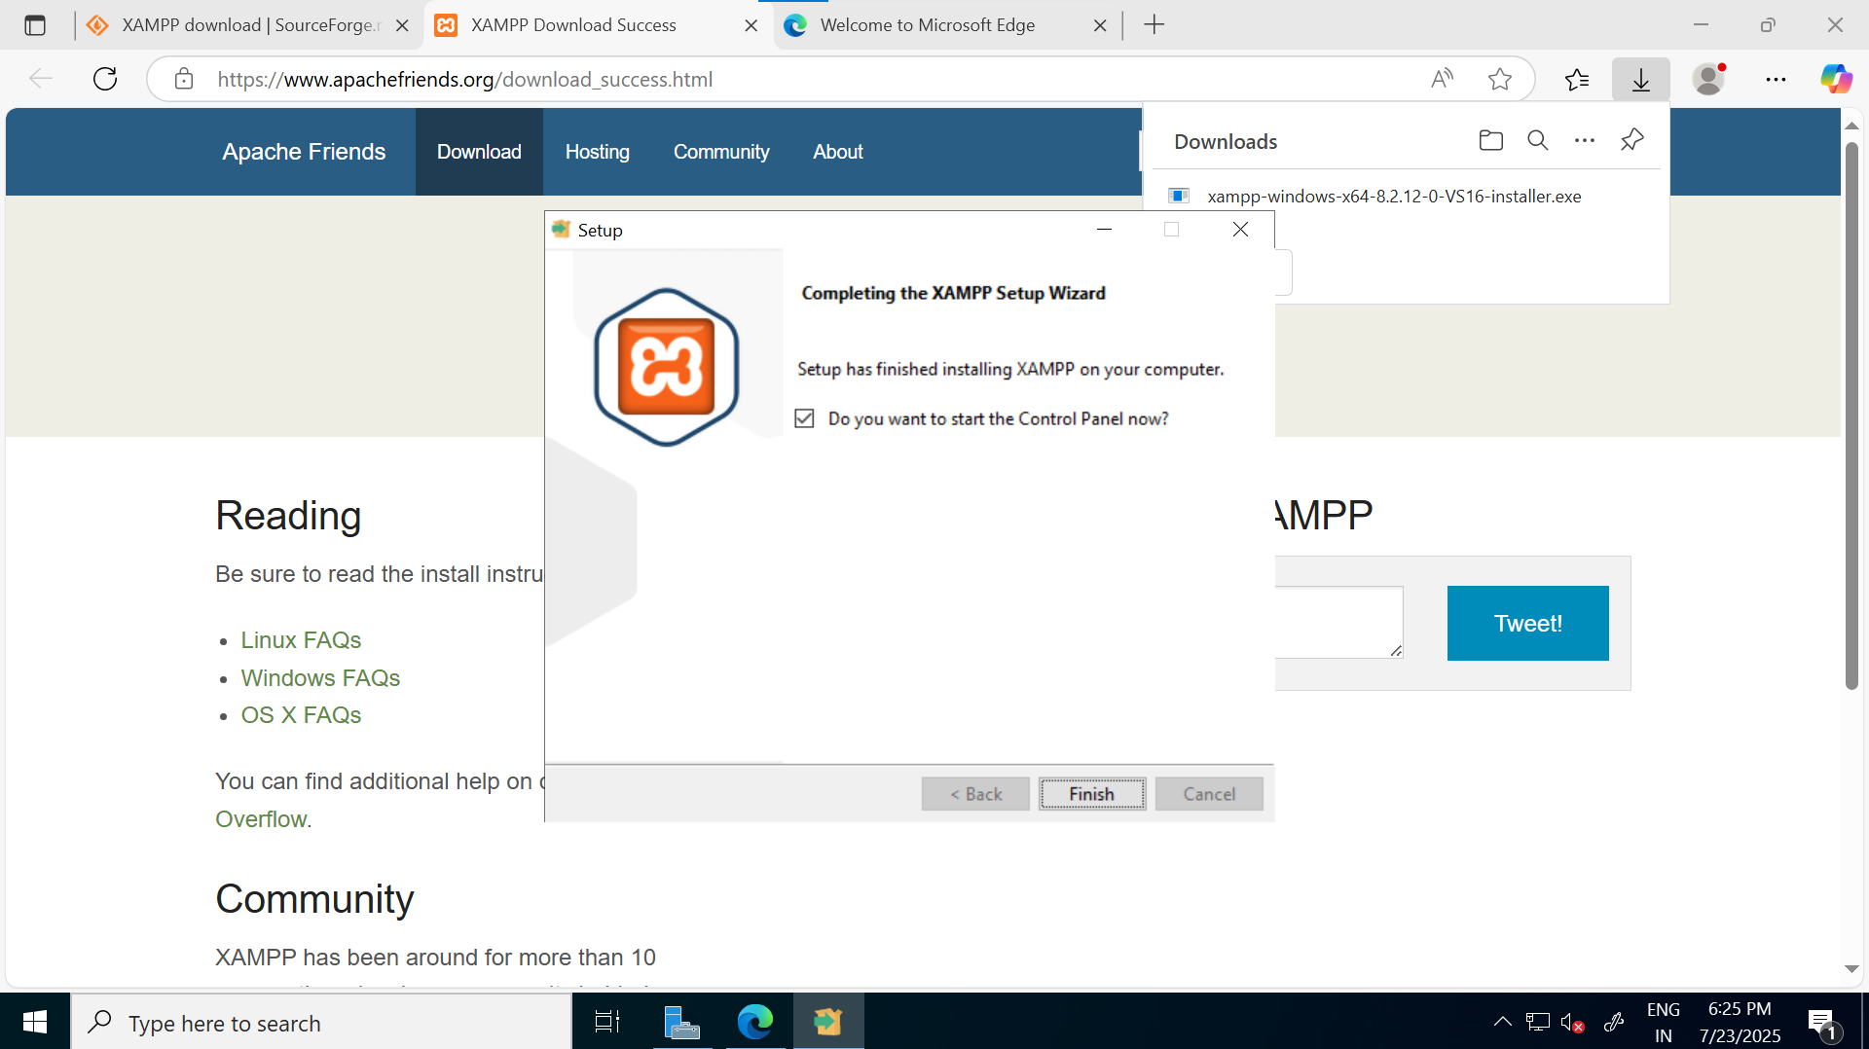

#### Start XAMPP Services

1. Open XAMPP Control Panel
2. Click "Start" next to Apache
3. Click "Start" next to MySQL
4. Services should show "Running" status

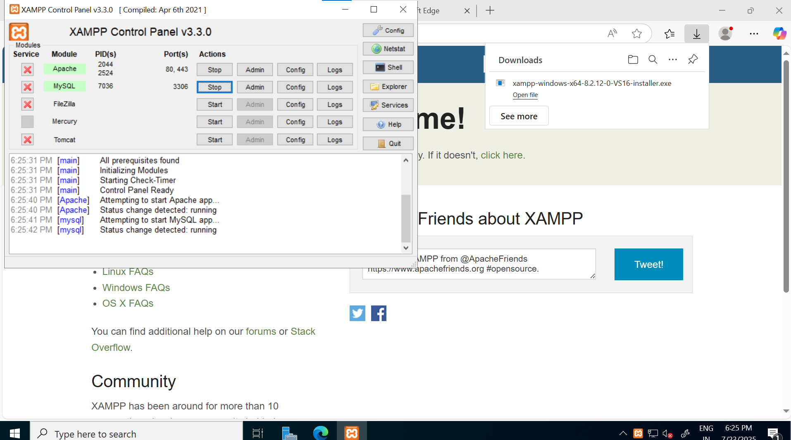

### Verifying XAMPP Installation

#### Test Default Page

1. Open web browser in Windows VM
2. Navigate to: http://localhost/dashboard/
3. You should see the XAMPP welcome page

